*Technical Report*

TSDSI

Self-Evaluation Report towards IMT-2020 Submission

COntents

1 Peak Spectral Efficiency 4

1.1 DL peak spectral efficiency 5

1.2 UL peak spectral efficiency 7

2 Peak Data Rate 8

2.1 DL peak data rate 9

2.2 UL peak data rate 9

3 User Plane Latency 10

3.1 Downlink 10

3.2 Uplink 14

4 Control Plane Latency 17

5 Mobility Interruption Time 23

5.1 Beam mobility 23

5.2 CA Mobility 24

6 Bandwidth and Scalability 24

7 Energy Efficiency 25

7.1 Network side 25

7.1.1 Evaluation of sleep ratio 26

7.1.2 Evaluation of sleep duration 27

7.2 Device side 28

7.2.1 Evaluation of sleep ratio 28

7.2.2 Evaluation of sleep duration 29

8 Spectrum 30

9 5th Percentile User Spectral Efficiency 31

10 Average Spectral Efficiency 31

10.1 Indoor Hotspot 31

10.2 Dense Urban 33

10.3 Rural e-MBB 34

10.3.1 Configuration A (700 MHz) 34

10.3.2 Configuration B (4 GHz) 36

10.3.3 LMLC (700 MHz) 37

11 User Experienced Data Rate 39

12 Area Traffic Capacity 40

13 Mobility 41

13.1 Indoor Hotspot – eMBB 41

13.2 Dense Urban – eMBB 41

13.3 Rural-eMBB 42

14 Reliability 43

14.1 DL reliability 43

14.2 UL reliability 43

15 Connection Density 44

16 Services 45

17 Conclusion 46

18 Link level assumption for mobility evaluation 46

18.1 Scaling factor for link level channel model 46

18.2 TXRU pattern and inter-port spacing in link level simulation 49

19 Evaluation assumption for peak spectral efficiency and peak data rate 49

20. Coverage Enhancement with Pi/2 BPSK and Spectrum Shaping 53

21. Detailed evaluation assumptions 55

a) Spectral Efficiency 55

b) Mobility 55

c) Reliability 55

d) Connection Density 55

Self-Evaluation Report of TSDSI RIT

This report presents the self-evaluation results of the TSDSI RIT described in the characteristics template. These results are based on simulations, observations and analytical approaches using procedures described in Report ITU-R M. 2412.

In this report, we provide details about all the KPI indicated in ITU-R M. 2410.

|  |  |  |  |  |  |
| --- | --- | --- | --- | --- | --- |
|  | **eMBB** | | | **mMTC** | **URLLC** |
| **KPI/Test environment** | **Indoor hostspot-eMBB** | **Dense Urban – eMBB** | **Rural – eMBB** | **Urban Macro – mMTC** | **Urban Macro – URLLC** |
| **System Simulation** |  |  |  |  |  |
| Average spectral efficiency (ASE) | **Sec 10** | **Sec 10** | **Sec 10** |  |  |
| 5th percentile user spectral efficiency (5SE) | **Sec 9-10** | **Sec 9-10** | **Sec 9-10** |  |  |
| Connection density |  |  |  | **Sec 15** |  |
| Mobility | **Sec 13** | **Sec 13** | **Sec 13** |  |  |
| Reliability |  |  |  |  | **Sec 14** |
| **Analytical approach** |  |  |  |  |  |
| Peak spectral efficiency | **Sec 1** | | |  |  |
| Peak data rate | **Sec 2** | | |  |  |
| User experienced data rate |  | **Sec 11** |  |  |  |
| Area traffic capacity | **Sec 12** |  |  |  |  |
| Control plane latency | **Sec 4** | **Sec 4** | **Sec 4** |  | **Sec 4** |
| User plane latency | **Sec 3** | **Sec 3** | **Sec 3** |  | **Sec 3** |
| Mobility interruption time | **Sec 5** | **Sec 5** | **Sec 5** |  | **Sec 5** |
| **Inspection approach** |  |  |  |  |  |
| Bandwidth | **Sec 8.** Maximum supported across all test environments | | | | |
| Energy efficiency | **Sec 7** | **Sec 7** | **Sec 7** |  |  |
| Services | **Sec 16** | | | | |

In the following, frequency ranges indicated by FR1 and FR2 are evaluated.

**Definition of frequency ranges**

|  |  |
| --- | --- |
| **Frequency range designation** | **Corresponding frequency range** |
| FR1 | 410 MHz – 7125 MHz |
| FR2 | 24250 MHz – 52600 MHz |

# Peak Spectral Efficiency

As per M.2410, peak spectral efficiency is the maximum data rate under ideal conditions divided by channel bandwidth (in bit/s/Hz), where the maximum data rate is the received data bits assuming error-free conditions assignable to a single mobile station, when all assignable radio resources for the corresponding link direction are utilized (i.e. excluding radio resources that are used for physical layer synchronization, reference signals or pilots, guard bands and guard times).

The generic formula for peak spectral efficiency for FDD and TDD for a specific component carrier (say *j-th CC (component carrier)*) is given by

 (1.1)

*Wherein,*

* *Rmax = 948/1024*
* *For the j-th CC,*
  + *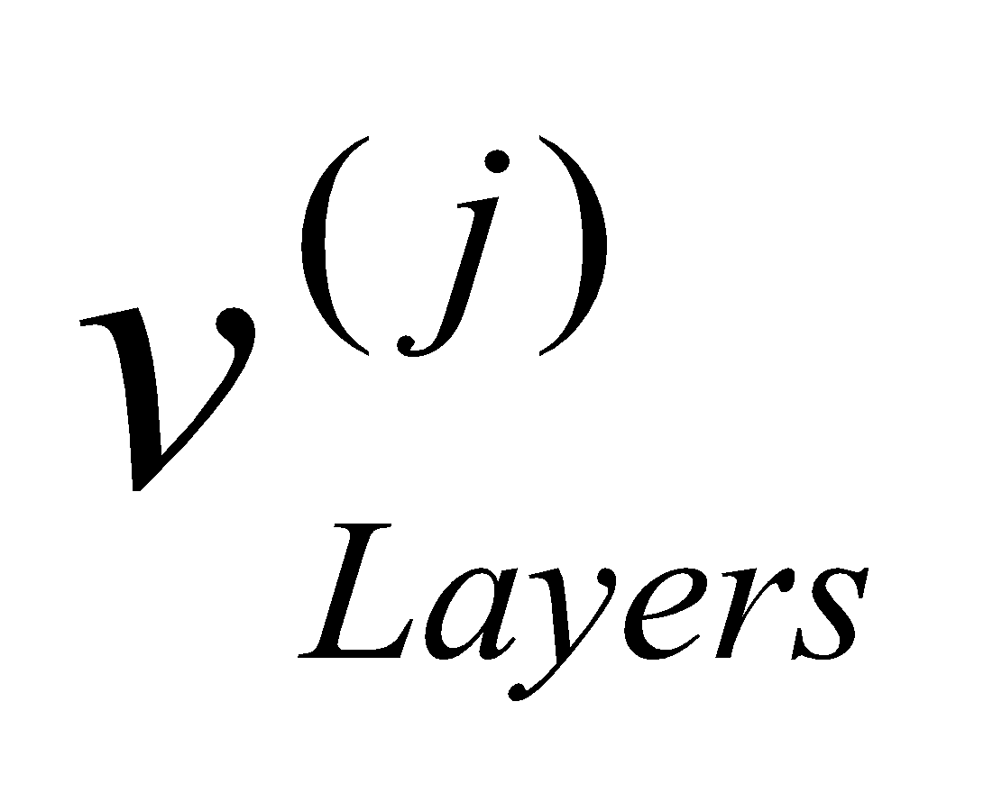 is the maximum number of layers*
  + * is the maximum modulation order*
  + *is the scaling factor* 
    - * *The scaling factor can at least take the values 1 and 0.75.*
      * *is signalled per band and per band per band combination as per UE capability signaling*
  + * is the numerology (as defined in T3.9038.211)*
  + * is the average OFDM symbol duration in a subframe for numerology , i.e. 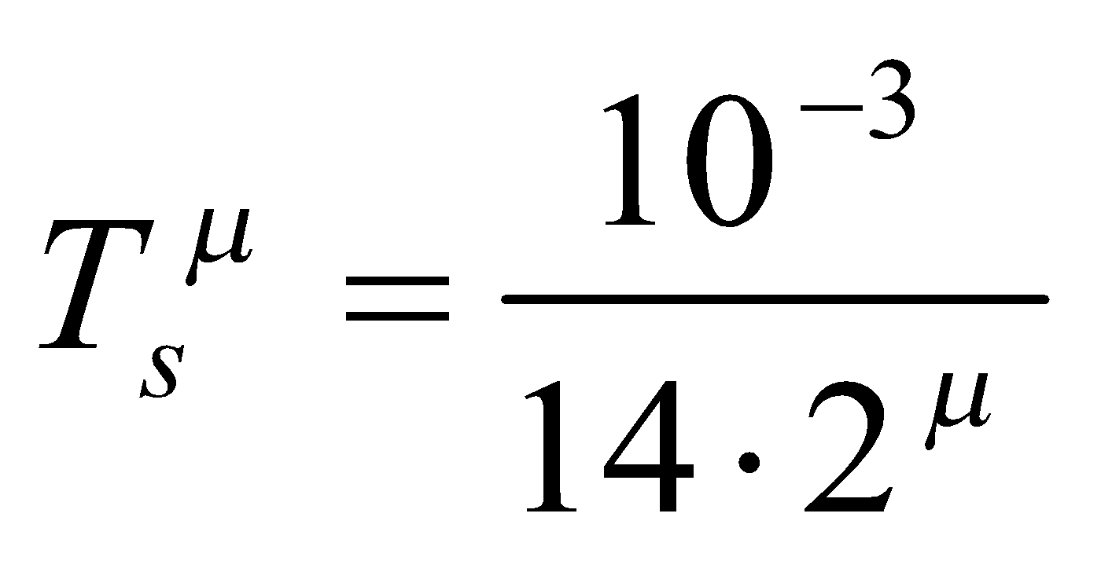. Note that normal cyclic prefix is assumed.*
  + * is the maximum RB allocation in bandwidth  with numerology , as given in T3.9038.104 section 5.3.2, where  is the UE supported maximum bandwidth in the given band or band combination.*
  + *is the overhead calculated as the average ratio of the number of REs occupied by L1/L2 control, Synchronization Signal, PBCH, reference signals and guard period (for TDD), etc. with respect to the total number of REs in effective bandwidth time product as given by* *.*

*− α(j) is the normalized scalar considering the downlink/uplink ratio; for FDD α(j)*=1 *for DL and UL; and for TDD and other duplexing α(j) for DL and UL is calculated based on the DL/UL configuration.*

*− For guard period (GP), 50% of GP symbols are considered as downlink overhead, and 50% of GP symbols are considered as uplink overhead.*

## DL peak spectral efficiency

A range of configurations are considered in the evaluation of downlink peak spectral efficiency. The evaluation considers the maximum potential capability as indicated in T3.9038.214.

For FDD, DL peak spectral efficiency of frequency range 1 (FR1) for 450 MHz – 7125 MHz is evaluated. The evaluated configurations for FDD generally assume 8-layer downlink transmission, with 256QAM modulation, and a maximum coding rate of 0.9258. The difference among the evaluated configurations lays in the overhead of control and reference signals, etc. The evaluation results are provided in Table 1.1.1. The detailed assumptions are provided in Section 19.

**Table 1.1.1 FDD DL peak spectral efficiency (bits/Hz)**

|  |  |  |  |  |  |  |  |  |  |  |  |  |  |  |
| --- | --- | --- | --- | --- | --- | --- | --- | --- | --- | --- | --- | --- | --- | --- |
| **SCS [kHz]** | | **5**  **MHz** | **10**  **MHz** | **15**  **MHz** | **20 MHz** | **25 MHz** | **30**  **MHz** | **40 MHz** | **50 MHz** | **60 MHz** | **80 MHz** | **90**  **MHz** | **100 MHz** | **Req.** |
| FR1 | 15 | 40.8~42.8 | 44.5~45.5 | 45.1~46.5 | 45.4~47.0 | 45.5~ 47.2 | 45.7~47.4 | 46.2~48.2 | 46.2~48.3 | - | - | - | - | 30 |
| 30 | 32.1~37.7 | 39.4~41.1 | 43.0~44.2 | 43.7~44.8 | 44.5~ 45.9 | 44.5~46.1 | 45.4~47.1 | 45.5~47.4 | 46.2~48.2 | 46.4~48.5 | 48.5~ 48.7 | 46.7~48.9 | 30 |
| 60 | - | 32.4~37.7 | 38.4~41.1 | 39.6~41.3 | 41.8~ 43.1 | 43.2~44.3 | 43.7~44.9 | 44.5~46.0 | 45.1~46.8 | 45.8~47.7 | 47.6~ 47.8 | 46.2~48.2 | 30 |

For TDD, DL peak spectral efficiency for both FR1 and FR2 for 24.25 GHz – 52.6 GHz are evaluated.

For TDD in FR1, the evaluated configurations generally assume 8-layer downlink transmission, with 256QAM modulation, and a maximum coding rate of 0.9258. The DL/UL configurations of DDDSU (with ‘S’ slot = 11DL:1GP:2UL) and DSUUD (with ‘S’ slot = 6DL:2GP:6UL and 11DL:1GP:2UL respectively) are evaluated.

The evaluation results of DDDSU for FR1 are provided in Table 1.1.2. In the evaluation, different control overhead assumptions are considered due to the different transmission schemes. The detailed assumptions are provided in Section 19.

**Table 1.1.2 TDD DL peak spectral efficiency for FR1 (bit/s/Hz)  
(Frame structure: DDDSU; *αDL*=0.7643; with OH1 and OH2)**

|  |  |  |  |  |  |  |  |  |  |  |  |  |  |  |
| --- | --- | --- | --- | --- | --- | --- | --- | --- | --- | --- | --- | --- | --- | --- |
| **SCS [kHz]** | | **5**  **MHz** | **10**  **MHz** | **15**  **MHz** | **20 MHz** | **25 MHz** | **30**  **MHz** | **40 MHz** | **50 MHz** | **60 MHz** | **80 MHz** | **90**  **MHz** | **100 MHz** | **Req.** |
| FR1 | 15 | 39.6~41.5 | 43.6~44.5 | 44.9~45.6 | 45.6~46.1 | 46.1~ 46.4 | 46.3~46.6 | 47.1~47.3 | 47.2~47.4 | - | - | - | - | 30 |
| 30 | 31.7~35.2 | 38.4~40.3 | 42.1~43.3 | 43.1~44.0 | 44.4~ 45.1 | 44.6~45.3 | 45.9~46.3 | 46.3~46.6 | 47.1~47.4 | 47.5~47.7 | 47.7~47.9 | 47.9~48.1 | 30 |
| 60 | - | 31.8~35.3 | 37.5~40.1 | 38.7~40.5 | 40.9~ 42.3 | 42.3~43.5 | 43.3~44.2 | 44.5~45.3 | 45.4~46.0 | 46.4~46.9 | 46.8~47.2 | 47.1~47.4 | 30 |

The evaluation results of DSUUD for the two S-slot configurations for FR1 are provided in Table 1.1.3. The detailed assumptions are provided in Section 19.

**Table 1.1.3 TDD DL peak spectral efficiency for FR1 (bit/s/Hz)  
(Frame structure: DSUUD)**

1. **S slot = 11DL:1GP:2UL, *αDL*=0.5643, with OH3**

|  |  |  |  |  |  |  |  |  |  |  |  |  |  |  |
| --- | --- | --- | --- | --- | --- | --- | --- | --- | --- | --- | --- | --- | --- | --- |
| **SCS [kHz]** | | **5**  **MHz** | **10**  **MHz** | **15**  **MHz** | **20 MHz** | **25 MHz** | **30**  **MHz** | **40 MHz** | **50 MHz** | **60 MHz** | **80 MHz** | **90**  **MHz** | **100 MHz** | **Req.** |
| FR1 | 15 | 39.1 | 43.1 | 44.5 | 45.2 | 45.6 | 45.9 | 46.7 | 46.8 | - | - | - | - | 30 |
| 30 | 30.4 | 38.0 | 41.7 | 42.7 | 44.0 | 44.3 | 45.5 | 45.9 | 46.8 | 47.1 | 47.4 | 47.6 | 30 |
| 60 | - | 31.0 | 37.1 | 38.4 | 40.6 | 42.0 | 42.9 | 44.2 | 45.1 | 46.1 | 46.5 | 46.8 | 30 |

**(b) S slot = 6DL:2GP:6UL, *αDL*=0.5, with OH4**

|  |  |  |  |  |  |  |  |  |  |  |  |  |  |  |
| --- | --- | --- | --- | --- | --- | --- | --- | --- | --- | --- | --- | --- | --- | --- |
| **SCS [kHz]** | | **5**  **MHz** | **10**  **MHz** | **15**  **MHz** | **20 MHz** | **25 MHz** | **30**  **MHz** | **40 MHz** | **50 MHz** | **60 MHz** | **80 MHz** | **90**  **MHz** | **100 MHz** | **Req.** |
| FR1 | 15 | 39.1 | 42.4 | 43.5 | 44.0 | 44.4 | 44.6 | 45.3 | 45.4 | - | - | - | - | 30 |
| 30 | 33.1 | 37.4 | 40.7 | 41.6 | 42.7 | 42.9 | 44.0 | 44.4 | 45.2 | 45.5 | 45.7 | 45.9 | 30 |
| 60 | - | 33.1 | 36.4 | 37.4 | 39.4 | 40.7 | 41.6 | 42.7 | 43.5 | 44.5 | 44.8 | 45.1 | 30 |

For TDD in FR2, the DL/UL configurations of DDDSU (with ‘S’ slot = 11DL:1GP:2UL) and DSUUD (with ‘S’ slot = 6DL:2GP:6UL and 11DL:1GP:2UL respectively) are evaluated. For FR2 evaluation, the number of layers is assumed to be 6. This is because larger than 6-port DMRS is difficult due to the phase noise impact on FR2. Besides, the highest modulation order of 256QAM and the maximum coding rate of 0.9258 are assumed.

The evaluation results of DDDSU and DSUUD for FR2 are provided in Table 1.1.4 and Table 1.1.5, respectively. The detailed assumptions are provided in Section 19.

**Table 1.1.4 TDD DL peak spectral efficiency for FR2 (bit/s/Hz)  
(Frame structure: DDDSU, *αDL*=0.7643, Number of layer = 6)**

|  |  |  |  |  |  |  |
| --- | --- | --- | --- | --- | --- | --- |
| **SCS [kHz]** | | **50 MHz** | **100 MHz** | **200 MHz** | **400 MHz** | **Req.** |
| FR2 | 60 | 33.7 | 34.5 | 34.9 | - | 30 |
| 120 | 31.7 | 34.0 | 34.7 | 35.0 | 30 |

**Table 1.1.5 TDD DL peak spectral efficiency for FR2 (bit/s/Hz)  
 (Frame structure: DSUUD, S slot = 11DL:1GP:2UL, *αDL*=0.5643, Number of layer = 6)**

|  |  |  |  |  |  |  |
| --- | --- | --- | --- | --- | --- | --- |
| **SCS [kHz]** | | **50 MHz** | **100 MHz** | **200 MHz** | **400 MHz** | **Req.** |
| FR2 | 60 | 32.9 | 33.8 | 34.2 | - | 30 |
| 120 | 31.1 | 33.5 | 34.2 | 34.6 | 30 |

If phase noise does not exist for FR2, the 8- layer transmission can be supported for FR2. The evaluation of this capability together with DSUUD is provided in Table 5.1.1.1-6.

**Table 1.1.6 TDD DL peak spectral efficiency for FR2 (bit/s/Hz)  
 (Frame structure: DSUUD, S slot = 6DL:2GP:6UL, *αDL*=0.5, Number of layer = 8)**

|  |  |  |  |  |  |  |
| --- | --- | --- | --- | --- | --- | --- |
| **SCS [kHz]** | | **50 MHz** | **100 MHz** | **200 MHz** | **400 MHz** | **Req.** |
| FR2 | 60 | 41.9 | 43.2 | 43.8 | - | 30 |
| 120 | 38.0 | 41.9 | 43.2 | 43.8 | 30 |

Based on the above analysis, RIT fulfils DL peak spectral efficiency requirement with a range of configurations.

## UL peak spectral efficiency

A range of configurations are considered in the evaluation of uplink peak spectral efficiency.

For FDD, UL peak spectral efficiency of FR1 is evaluated. The evaluated configurations for FDD generally assume 4-layer downlink transmission, with 256QAM modulation, and a maximum coding rate of 0.9258. The difference among the evaluated configurations lays in the overhead of control and reference signals, etc. The evaluation results are provided in Table 1.2.1. The detailed assumptions are provided in Section 19.

**Table 1.2.1 FDD UL peak spectral efficiency (bit/s/Hz)**

|  |  |  |  |  |  |  |  |  |  |  |  |  |  |  |
| --- | --- | --- | --- | --- | --- | --- | --- | --- | --- | --- | --- | --- | --- | --- |
| **SCS [kHz]** | | **5**  **MHz** | **10**  **MHz** | **15**  **MHz** | **20 MHz** | **25 MHz** | **30**  **MHz** | **40 MHz** | **50 MHz** | **60 MHz** | **80 MHz** | **90**  **MHz** | **100 MHz** | **Req.** |
| FR1 | 15 | 22.9~23.5 | 23.8~24.5 | 24.1~24.8 | 24.3~25.0 | 24.4~25.1 | 24.4~ 25.2 | 24.7~25.5 | 24.7~25.5 | - | - | - | - | 15 |
| 30 | 20.1~20.7 | 22.0~22.6 | 23.2~23.9 | 23.4~24.1 | 23.8~24.6 | 23.8~ 24.6 | 24.3~25.1 | 24.4~25.2 | 24.7~25.5 | 24.8~25.7 | 24.9~ 25.3 | 25.0~25.8 | 15 |
| 60 | - | 20.1~20.7 | 22.0~22.6 | 22.0~22.7 | 22.7~23.4 | 23.2~ 23.9 | 23.4~24.1 | 23.8~24.6 | 24.1~24.9 | 24.5~25.3 | 24.9~ 25.0 | 24.7~25.6 | 15 |

For TDD, UL peak spectral efficiency for both FR1 and FR2 are evaluated. For TDD in FR1, the evaluated configurations generally assume 4-layer uplink transmission, with 256QAM modulation, and a maximum coding rate of 0.9258. The DL/UL configurations of DDDSU (with ‘S’ slot = 11DL:1GP:2UL) and DSUUD (with ‘S’ slot = 6DL:2GP:6UL and 11DL:1GP:2UL respectively) are evaluated.

The evaluation results of DDDSU for FR1 are provided in Table 1.2.2 In the evaluation, different control overhead assumptions are considered due to the different transmission schemes. The detailed assumptions are provided in Section 19.

**Table 1.2.2 TDD UL peak spectral efficiency for FR1 (bit/s/Hz)  
(Frame structure: DDDSU, *αuL*=0.2357, with OH1 and OH2)**

|  |  |  |  |  |  |  |  |  |  |  |  |  |  |  |
| --- | --- | --- | --- | --- | --- | --- | --- | --- | --- | --- | --- | --- | --- | --- |
| **SCS [kHz]** | | **5**  **MHz** | **10**  **MHz** | **15**  **MHz** | **20 MHz** | **25 MHz** | **30**  **MHz** | **40 MHz** | **50 MHz** | **60 MHz** | **80 MHz** | **90**  **MHz** | **100 MHz** | **Req.** |
| FR1 | 15 | 20.6~21.6 | 21.5~22.6 | 21.8~22.9 | 22.0~23.0 | 22.0~23.1 | 22.1~ 23.2 | 22.4~23.5 | 22.4~23.5 | - | - | - | - | 15 |
| 30 | 18.2~19.1 | 20.0~20.9 | 21.1~22.1 | 21.3~22.3 | 21.7~22.8 | 21.7~ 22.8 | 22.2~23.2 | 22.2~23.2 | 22.6~23.7 | 22.7~23.8 | 22.8~ 23.9 | 22.8~23.9 | 15 |
| 60 | - | 18.3~19.1 | 20.0~21.0 | 20.1~21.0 | 20.8~21.8 | 21.2~ 22.2 | 21.4~22.4 | 21.8~22.9 | 22.1~23.2 | 22.5~23.5 | 22.6~ 23.7 | 22.7~23.8 | 15 |

The evaluation results of DSUUD for the two S-slot configurations for FR1 are provided in Table 1.2.3. The detailed assumptions for the two configurations are provided in Section 19.

**Table 1.2.3 TDD UL peak spectral efficiency for FR1 (bit/s/Hz)  
(Frame structure: DSUUD)**

1. **S slot = 11DL:1GP:2UL, *αUL*=0.4357, with OH3**

|  |  |  |  |  |  |  |  |  |  |  |  |  |  |  |
| --- | --- | --- | --- | --- | --- | --- | --- | --- | --- | --- | --- | --- | --- | --- |
| **SCS [kHz]** | | **5**  **MHz** | **10**  **MHz** | **15**  **MHz** | **20 MHz** | **25 MHz** | **30**  **MHz** | **40 MHz** | **50 MHz** | **60 MHz** | **80 MHz** | **90**  **MHz** | **100 MHz** | **Req.** |
| FR1 | 15 | 22.1 | 23.1 | 23.4 | 23.6 | 23.7 | 23.8 | 24.0 | 24.0 | - | - | - | - | 15 |
| 30 | 19.4 | 21.3 | 22.5 | 22.7 | 23.1 | 23.1 | 23.6 | 23.7 | 24.1 | 24.2 | 24.3 | 24.3 | 15 |
| 60 | - | 19.4 | 21.3 | 21.3 | 22.0 | 22.5 | 22.7 | 23.2 | 23.4 | 23.8 | 24.0 | 24.0 | 15 |

**(b) S slot = 6DL:2GP:6UL, *αUL*=0.5, with OH4**

|  |  |  |  |  |  |  |  |  |  |  |  |  |  |  |
| --- | --- | --- | --- | --- | --- | --- | --- | --- | --- | --- | --- | --- | --- | --- |
| **SCS [kHz]** | | **5**  **MHz** | **10**  **MHz** | **15**  **MHz** | **20 MHz** | **25 MHz** | **30**  **MHz** | **40 MHz** | **50 MHz** | **60 MHz** | **80 MHz** | **90**  **MHz** | **100 MHz** | **Req.** |
| FR1 | 15 | 21.7 | 23.0 | 23.4 | 23.6 | 23.7 | 23.8 | 24.1 | 24.1 | - | - | - | - | 15 |
| 30 | 18.3 | 20.8 | 22.2 | 22.5 | 23.0 | 23.1 | 23.6 | 23.7 | 24.2 | 24.3 | 24.4 | 24.2 | 15 |
| 60 | - | 18.3 | 20.6 | 20.8 | 21.7 | 22.2 | 22.5 | 23.0 | 23.8 | 23.9 | 24.1 | 23.8 | 15 |

For TDD in FR2, the evaluated configurations generally assume 4-layer uplink transmission, with 256QAM modulation, and a maximum coding rate of 0.9258. The DL/UL configurations of DDDSU (with ‘S’ slot = 11DL:1GP:2UL) and DSUUD (with ‘S’ slot = 6DL:2GP:6UL and 11DL:1GP:2UL respectively) are evaluated.

The evaluation results of DDDSU and DSUUD for FR2 are provided in Table 1.2.4 and Table 1.2.5, respectively. The detailed assumptions are provided in Section 19.

**Table 1.2.4 TDD UL peak spectral efficiency for FR2 (bit/s/Hz)  
(Frame structure: DDDSU, *αuL*=0.2357)**

|  |  |  |  |  |  |  |
| --- | --- | --- | --- | --- | --- | --- |
| **SCS [kHz]** | | **50 MHz** | **100 MHz** | **200 MHz** | **400 MHz** | **Req.** |
| FR2 | 60 | 20.9 | 21.0 | 21.0 | - | 15 |
| 120 | 20.4 | 21.1 | 21.2 | 21.2 | 15 |

**Table 1.2.5 TDD UL peak spectral efficiency for FR2 (bit/s/Hz)  
(Frame structure: DSUUD)**

1. **S** **slot = 11DL:1GP:2UL, *αuL*=0.4357**

|  |  |  |  |  |  |  |
| --- | --- | --- | --- | --- | --- | --- |
| **SCS [kHz]** | | **50 MHz** | **100 MHz** | **200 MHz** | **400 MHz** | **Req.** |
| FR2 | 60 | 21.8 | 21.9 | 21.9 | - | 15 |
| 120 | 21.3 | 22.0 | 22.1 | 22.1 | 15 |

**(b) S slot = 6DL:2GP:6UL, *αUL*=0.5**

|  |  |  |  |  |  |  |
| --- | --- | --- | --- | --- | --- | --- |
| **SCS [kHz]** | | **50 MHz** | **100 MHz** | **200 MHz** | **400 MHz** | **Req.** |
| FR2 | 60 | 23.0 | 23.1 | 23.2 | - | 15 |
| 120 | 22.0 | 23.0 | 23.1 | 23.2 | 15 |

Based on the above analysis, the RIT fulfils UL peak spectral efficiency requirement with a range of configurations.

# Peak Data Rate

As defined in Report ITU-R M.2410, peak data rate is the maximum achievable data rate under ideal conditions (in bit/s), which is the received data bits assuming error-free conditions assignable to a single mobile station, when all assignable radio resources for the corresponding link direction are utilized (i.e. excluding radio resources that are used for physical layer synchronization, reference signals or pilots, guard bands and guard times).

The DL/UL peak data rate for FDD and TDD over *Q* component carriers can be calculated as below



where *Wj* and *Se*p*i* (*j* = 1,…, *Q*) are the effective bandwidth and spectral efficiencies on component carrier *j*, respectively, *α*(*j*) is the normalized scalar on component carrier *j* considering the downlink/uplink ratio on that component carrier; for FDD *α*(*j*) =1 for DL and UL; and for TDD and other duplexing *α*(*j*) for DL and UL is calculated based on the frame structure, and *BW*(*j*) is the carrier bandwidth of component *j*.

## DL peak data rate

A range of configurations are considered in the evaluation of downlink peak data rate.

DL peak data rate is evaluated based on the evaluation results of the peak spectral efficiency provided in Section 1. Table 2.1.1. provides the evaluation results for the specific component carrier (CC) bandwidth. It is observed that the RIT fulfils the DL peak data rate requirement.

**Table 2.1.1 DL peak data rate**

|  |  |  |  |  |  |  |  |
| --- | --- | --- | --- | --- | --- | --- | --- |
| **Duplexing** | **SCS [kHz]** | | **Per CC BW (MHz)** | **Peak data rate per CC (Gbit/s)** | **Aggregated peak data rate over 16 CCs (Gbit/s)** | **Required DL bandwidth to meet the requirement (MHz)1** | **Req. (Gbit/s)** |
| FDD | FR1 | 15 | 50 | 2.31~2.41 | 37.0~38.6 | 414~433 | 20 |
| 30 | 100 | 4.67~4.89 | 74.7~78.2 | 409~428 |
| 60 | 100 | 4.62~4.82 | 73.9~77.1 | 415~433 |
| TDD  (DDDSU) | FR1 | 15 | 50 | 1.81 | 29.0 | 552 |
| 30 | 100 | 3.68 | 58.9 | 543 |
| 60 | 100 | 3.62 | 57.9 | 552 |
| FR2  (*Nlayer*=6) | 60 | 200 | 5.33 | 85.3 | 750 |
| 120 | 400 | 10.7 | 171.2 | 748 |
| TDD  (DSUUD,  S slot= 11DL:2GP:2UL) | FR1 | 15 | 50 | 1.32 | 21.1 | 757 |
| 30 | 100 | 2.69 | 43.0 | 745 |
| 60 | 100 | 2.64 | 42.3 | 757 |
| FR2  (*Nlayer*=6) | 60 | 200 | 3.86 | 61.8 | 1036 |
| 120 | 400 | 7.81 | 125.0 | 1024 |
| TDD  (DSUUD,  S slot= 6DL:2GP:6UL) | FR1 | 15 | 50 | 1.13 | 18.1 | 885 |
| 30 | 100 | 2.30 | 36.8 | 870 |
| 60 | 100 | 2.26 | 36.2 | 885 |
| FR2 (*Nlayer*=8) | 60 | 200 | 4.38 | 70.1 | 913 |
| 120 | 400 | 8.76 | 140.2 | 913 |
| NOTE 1: The value only indicates the required bandwidth to meet the DL peak data rate. It is not necessarily supported as the Transmission bandwidth. | | | | | | | |

## UL peak data rate

A range of configurations are considered in the evaluation of uplink peak data rate.

UL peak data rate is evaluated based on the evaluation results of peak spectral efficiency provided in Section 1. Table 2.2.1 provides the evaluation results for the specific component carrier (CC) bandwidth. It is observed that the RIT fulfils the UL peak data rate requirement.

**Table 2.2.1 UL peak data rate**

|  |  |  |  |  |  |  |  |
| --- | --- | --- | --- | --- | --- | --- | --- |
| **Duplexing** | **SCS [kHz]** | | **Per CC BW (MHz)** | **Peak data rate per CC (Gbit/s)** | **Aggregated peak data rate over 16 CCs (Gbit/s)** | **Required UL bandwidth to meet the requirement (MHz)1** | **Req. (Gbit/s)** |
| FDD | FR1 | 15 | 50 | 1.12~1.18 | 17.9~18.9 | 424~446 | 10 |
| 30 | 100 | 2.28~2.39 | 36.5~38.2 | 418~439 |
| 60 | 100 | 2.27~2.38 | 36.3~38.1 | 420~441 |
| TDD (DDDSU) + SUL | FR1 | 15 | 50 | 1.12~1.18 | 17.9~18.9 | 424~446 |
| 30 | 100 | 2.28~2.39 | 36.5~38.2 | 418~439 |
| 60 | 100 | 2.27~2.38 | 36.3~38.1 | 420~441 |
| TDD  (DSUUD,  S slot =11DL:2GP:2UL) | FR1 | 30 | 100 | 1.06 | 17.0 | 943 |
| 60 | 100 | 1.05 | 16.8 | 952 |
| FR2 | 60 | 200 | 1.91 | 30.6 | 1047 |
| 120 | 400 | 3.85 | 61.6 | 1039 |
| TDD  (DSUUD,  S slot =6DL:2GP:6UL) | FR1 | 30 | 100 | 1.05 | 16.8 | 952 |
| 60 | 100 | 1.04 | 16.6 | 962 |
| FR2 | 60 | 200 | 2.02 | 32.3 | 990 |
| 120 | 400 | 4.04 | 64.6 | 990 |
| NOTE 1: The value only indicates the required bandwidth to meet the DL peak data rate. It is not necessarily supported as the Transmission bandwidth. | | | | | | | |

# User Plane Latency

As defined in Report ITU-R M.2410, user plane latency is the contribution of the radio network to the time from when the source sends a packet to when the destination receives it (in ms). The evaluation of TSDSI RIT user plane latency is based on the procedure illustrated in Figure 3.1.

**Figure 3.1 User plane procedure for evaluation**

The detailed assumptions of each step are provided in Table 3.1.1 and Table 3.2.1 for downlink and uplink, respectively.

The additional assumptions to derive the evaluation results of the proposed RIT user plane latency are list as below.

* It is assumed that the packet arrives at any time of any OFDM symbol. In this case, the 0.5symbol length is added as the “average symbol alignment time” at the beginning of the procedure.
* The transmission of PDCCH, PDSCH, PUCCH, PUSCH cannot be across the slot. Otherwise the transmission will wait for the next slot.
* The PDSCH/PUSCH allocation (transmission duration) of 2/4/7/14-os non-slot or slot are evaluated.
* If the evaluation is for 14 OFDM Symbol length slot, then slot based scheduling is used.
* Otherwise non-slot based scheduling is used.
* The resource mapping type A and B are considered, which impact the start timing of a transmission. Details on resource mapping mechanism can be found in [T3 9038.214].
* It is assumed that PDCCH monitoring occasion occurs at every OFDM symbol in the evaluation.

## Downlink

The downlink procedure is abstracted in Table 3.1.1, where the assumptions of each step for evaluation are given.

**Table 3.1.1 DL user plane procedure**

|  |  |  |  |
| --- | --- | --- | --- |
| **ID** | **Component** | **Notations** | **Value** |
| 1 | DL data transfer | *T*1 = (*t*BS,tx + *t*FA,DL) + *t*DL_duration + *t*UE,rx |  |
| 1.1 | BS processing delay | *t*BS,tx  The time interval between the data is arrived, and packet is generated. | Tproc,2/2, with d2,1= d2,2= d2,3=0. (Tproc,2 is defined in Section 6.4 of T3.9038.214) (NOTE1, NOTE2) |
| 1.2 | DL Frame alignment (transmission alignment) | *t*FA,DL  It includes frame alignment time, and the waiting time for next available DL slot | *T*FA + *T*wait,  *T*FA is the frame alignment time within the current DL slot;  *T*wait is the waiting time for next available DL slot if the current slot is not DL slot. |
| 1.3 | TTI for DL data packet transmission | *t*DL_duration | Length of one slot (14 OFDM symbol length) or non-slot (2/4/7 OFDM symbol length), depending on slot or non-slot selected in evaluation. |
| 1.4 | UE processing delay | *t*UE,rx  The time interval between the PDSCH is received and the data is decoded; | Tproc,1/2 (Tproc,1 is defined in Section 5.3 of T3.9038.214), d1,1=0; d1,2 should be selected according to resource mapping type and UE capability. *N*1*=*the value with “No additional PDSCH DM-RS configured”. (NOTE3) |
| 2 | HARQ retransmission | *T*HARQ = *T*1 + *T*2  *T*2 = (*t*UE,tx + *t*FA,UL)+ *t*UL_duration + *t*BS,rx (For Steps 2.1 to 2.4) |  |
| 2.1 | UE processing delay | *t*UE,tx  The time interval between the data is decoded, and ACK/NACK packet is generated. | Tproc,1/2 (Tproc,1 is defined in Section 5.3 of T3.9038.214), d1,1=0; d1,2 should be selected according to resource mapping type and UE capability. *N*1*=*the value with “No additional PDSCH DM-RS configured”. (NOTE4) |
| 2.2 | UL frame alignment (transmission alignment) | *t*FA,UL  It includes frame alignment time, and the waiting time for the next available UL slot | *T*FA + *T*wait,  *T*FA is the frame alignment time within the current UL slot;  *T*wait is the waiting time for next available UL slot if the current slot is not UL slot |
| 2.3 | TTI for ACK/NACK transmission | *t*UL_duration | 1 OFDM symbol |
| 2.4 | BS processing delay | *t*BS,rx  The time interval between the ACK is received and the ACK is decoded. | Tproc, 2/2 with d2,1= d2,2= d2,3=0. (NOTE1, NOTE5) |
| 2.5 | Repeat DL data transfer from 1.1 to 1.4 | *T*1 |  |
| - | Total one way user plane latency for DL | *T*UP= *T*1 + *n*×*T*HARQ  where *n* is the number of re-transmissions (*n*≥0) | |
| Note:  1. The value is used for evaluation only; gNB processing delay may vary depending on implementation.  2. For the case of a TDD band (30 kHz SCS) with an SUL band (15 kHz SCS), the value of this step is Tproc,2(μ =30kHz) / 2 for Initial transmission, and Tproc,2(μ =15kHz) / 2 for re-transmission.  3. For the above case, the UE is processing PDSCH reception on TDD band with 30kHz SCS, and it is assumed that the value of this step is Tproc,1(μ =30kHz)/2.  4. For the above case, the value of this step is Tproc,1(μ =15kHz) – Tproc,1(μ =30kHz)/2.  5. For the above case, the value of this step is Tproc,2(μ =15kHz)/2. | | | |

Based on the DL user plane procedure and assumptions given in Table 5.7.1.1.1-1, a variety of configurations and UE capabilities are evaluated.

For FDD, the evaluation results assuming an initial transmission error probability of *p*=0 and *p*=0.1 are provided in Table 3.1.2

**Table 3.1.2 DL user plane latency for FDD (ms)**

|  |  |  |  |  |  |  |  |  |  |  |  |
| --- | --- | --- | --- | --- | --- | --- | --- | --- | --- | --- | --- |
| DL user plane latency –FDD | | | UE capability 1 | | | | | UE capability 2 | | | |
| SCS | | | | | SCS | | | |
| 15 kHz | 30 kHz | 60 kHz | 120 kHz | 15 kHz | | 30 kHz | 60 kHz |
| **Resource mapping Type A** | M=4 (4OS non-slot) | p=0 | 1.37 | 0.76 | 0.54 | 0.34 | 1.00 | | 0.55 | 0.36 |
| p=0.1 | 1.58 | 0.87 | 0.64 | 0.40 | 1.12 | | 0.65 | 0.41 |
| M=7 (7OS non-slot) | p=0 | 1.49 | 0.82 | 0.57 | 0.36 | 1.12 | | 0.61 | 0.39 |
| p=0.1 | 1.70 | 0.93 | 0.67 | 0.42 | 1.25 | | 0.71 | 0.44 |
| M=14 (14OS slot) | p=0 | 2.13 | 1.14 | 0.72 | 0.44 | 1.80 | | 0.94 | 0.56 |
| p=0.1 | 2.43 | 1.29 | 0.82 | 0.51 | 2.00 | | 1.04 | 0.63 |
| **Resource mapping Type B** | M=2 (2OS non-slot) | p=0 | 0.98 | 0.56 | 0.44 | 0.29 | 0.49 | | 0.29 | 0.23 |
| p=0.1 | 1.16 | 0.67 | 0.52 | 0.35 | 0.60 | | 0.35 | 0.28 |
| M=4 (4OS non-slot) | p=0 | 1.11 | 0.63 | 0.47 | 0.31 | 0.66 | | 0.37 | 0.27 |
| p=0.1 | 1.30 | 0.74 | 0.56 | 0.36 | 0.78 | | 0.45 | 0.32 |
| M=7 (7OS non-slot) | p=0 | 1.30 | 0.72 | 0.52 | 0.33 | 0.93 | | 0.51 | 0.34 |
| p=0.1 | 1.49 | 0.83 | 0.61 | 0.39 | 1.08 | | 0.59 | 0.40 |

For TDD, the various DL/UL configurations are evaluated. The evaluation results of DDDSU (with S slot = 11DL:1GP:2UL), DSUUD (with S slot = 11DL:1GP:2UL), and DUDU (without GP) are provided in Table 3.1.3, Table 3.1.4, and Table 3.1.5, respectively.

**Table 3.1.3 DL user plane latency for TDD (ms)  
(Frame structure: DDDSU)**

|  |  |  |  |  |  |  |  |  |
| --- | --- | --- | --- | --- | --- | --- | --- | --- |
| DL user plane latency – TDD (DDDSU) | | | UE capability 1 | | | UE capability 2 | | |
| SCS | | | SCS | | |
| 15 kHz | 30 kHz | 60 kHz | 15 kHz | 30 kHz | 60 kHz |
| **Resource mapping Type A** | M=4 (4OS non-slot) | p=0 | 1.57 | 0.86 | 0.58 | 1.18 | 0.65 | 0.40 |
| p=0.1 | 1.95 | 1.05 | 0.70 | 1.56 | 0.84 | 0.50 |
| M=7 (7OS non-slot) | p=0 | 1.69 | 0.92 | 0.61 | 1.30 | 0.71 | 0.43 |
| p=0.1 | 2.07 | 1.11 | 0.73 | 1.67 | 0.90 | 0.53 |
| M=14 (14OS slot) | p=0 | 2.38 | 1.26 | 0.78 | 1.99 | 1.06 | 0.60 |
| p=0.1 | 2,78 | 1.46 | 0.93 | 2.37 | 1.25 | 0.70 |
| **Resource mapping Type B** | M=2 (2OS non-slot) | p=0 | 1.16 | 0.65 | 0.48 | 0.66 | 0.39 | 0.27 |
| p=0.1 | 1.52 | 0.83 | 0.59 | 1.02 | 0.57 | 0.36 |
| M=4 (4OS non-slot) | p=0 | 1.28 | 0.71 | 0.51 | 0.82 | 0.47 | 0.31 |
| p=0.1 | 1.64 | 0.90 | 0.63 | 1.17 | 0.65 | 0.40 |
| M=7 (7OS non-slot) | p=0 | 1.49 | 0.82 | 0.56 | 1.10 | 0.61 | 0.38 |
| p=0.1 | 1.86 | 1.01 | 0.69 | 1.47 | 0.80 | 0.47 |

**Table 3.1.4 DL user plane latency for TDD (ms)  
(Frame structure: DSUUD)**

|  |  |  |  |  |  |  |  |  |  |  |
| --- | --- | --- | --- | --- | --- | --- | --- | --- | --- | --- |
| DL user plane latency – TDD (DSUUD) | | | UE capability 1 | | | | | UE capability 2 | | |
| SCS | | | | | SCS | | |
| 15 kHz | 30 kHz | 60 kHz | 120 kHz | 15 kHz | | 30 kHz | 60 kHz |
| **Resource mapping Type A** | M=4 (4OS non-slot) | p=0 | 1.93 | 1.04 | 0.68 | 0.41 | 1.56 | | 0.82 | 0.48 |
| p=0.1 | 2.37 | 1.26 | 0.78 | 0.48 | 1.99 | | 1.04 | 0.59 |
| M=7 (7OS non-slot) | p=0 | 2.05 | 1.1 | 0.71 | 0.43 | 1.69 | | 0.88 | 0.53 |
| p=0.1 | 2.49 | 1.32 | 0.83 | 0.5 | 2.13 | | 1.1 | 0.64 |
| M=14 (14OS slot) | p=0 | 2.74 | 1.44 | 0.88 | 0.51 | 2.39 | | 1.23 | 0.7 |
| p=0.1 | 3.19 | 1.66 | 1 | 0.58 | 2.83 | | 1.45 | 0.81 |
| **Resource mapping Type B** | M=2 (2OS non-slot) | p=0 | 1.47 | 0.81 | 0.56 | 0.35 | 1.01 | | 0.54 | 0.36 |
| p=0.1 | 1.9 | 1.02 | 0.67 | 0.41 | 1.43 | | 0.75 | 0.47 |
| M=4 (4OS non-slot) | p=0 | 1.59 | 0.87 | 0.59 | 0.37 | 1.16 | | 0.62 | 0.4 |
| p=0.1 | 2.01 | 1.08 | 0.7 | 0.43 | 1.58 | | 0.83 | 0.5 |
| M=7 (7OS non-slot) | p=0 | 1.83 | 0.99 | 0.65 | 0.4 | 1.47 | | 0.77 | 0.48 |
| p=0.1 | 2.26 | 1.2 | 0.76 | 0.46 | 1.9 | | 0.99 | 0.58 |

**Table 3.1.5 DL user plane latency for TDD (ms)  
(Frame structure: DUDU)**

|  |  |  |  |  |  |  |  |  |  |  |
| --- | --- | --- | --- | --- | --- | --- | --- | --- | --- | --- |
| DL user plane latency – TDD (DU) | | | UE capability 1 | | | | | UE capability 2 | | |
| SCS | | | | | SCS | | |
| 15 kHz | 30 kHz | 60 kHz | 120 kHz | 15 kHz | | 30 kHz | 60 kHz |
| **Resource mapping Type A** | M=4 (4OS non-slot) | p=0 | 1.83 | 1.00 | 0.64 | 0.40 | 1.47 | | 0.77 | 0.48 |
| p=0.1 | 2.04 | 1.11 | 0.73 | 0.48 | 1.66 | | 0.87 | 0.52 |
| M=7 (7OS non-slot) | p=0 | 1.94 | 1.04 | 0.65 | 0.41 | 1.59 | | 0.83 | 0.50 |
| p=0.1 | 2.16 | 1.16 | 0.75 | 0.49 | 1.79 | | 0.93 | 0.55 |
| M=14 (14OS slot) | p=0 | 2.61 | 1.38 | 0.83 | 0.50 | 2.29 | | 1.18 | 0.68 |
| p=0.1 | 2.96 | 1.55 | 0.96 | 0.58 | 2.49 | | 1.29 | 0.78 |
| **Resource mapping Type B** | M=2 (2OS non-slot) | p=0 | 1.27 | 0.71 | 0.51 | 0.33 | 0.76 | | 0.42 | 0.30 |
| p=0.1 | 1.46 | 0.81 | 0.61 | 0.39 | 0.99 | | 0.53 | 0.36 |
| M=4 (4OS non-slot) | p=0 | 1.46 | 0.80 | 0.56 | 0.35 | 0.98 | | 0.54 | 0.36 |
| p=0.1 | 1.65 | 0.91 | 0.66 | 0.41 | 1.22 | | 0.65 | 0.41 |
| M=7 (7OS non-slot) | p=0 | 1.71 | 0.93 | 0.63 | 0.38 | 1.32 | | 0.71 | 0.44 |
| p=0.1 | 1.91 | 1.03 | 0.73 | 0.46 | 1.55 | | 0.81 | 0.50 |

In addition, supports X slot that can be flexibly configured based on the traffic pattern. The evaluation of DDDXU is provided for this capability, where ‘X’ slot = ‘D’ slot for DL data transmission, and ‘X’=‘U’ for ACK/NACK feedback for DL user plane latency evaluation. The evaluation results are provided in Table 3.1.6.

**Table 3.1.6 DL user plane latency for TDD (ms)  
(Frame structure: DDDXU, with ‘X’=’D’ for DL traffic)**

|  |  |  |  |  |  |  |  |  |  |  |  |
| --- | --- | --- | --- | --- | --- | --- | --- | --- | --- | --- | --- |
| DL user plane latency – TDD (DDDXU) | | | UE capability 1 | | | | | UE capability 2 | | | |
| SCS | | | | | SCS | | | |
| 15 kHz | 30 kHz | 60 kHz | 120 kHz | 15 kHz | | 30 kHz | 60 kHz |
| **Resource mapping Type A** | M=14 (14OS slot) | p=0 | 2.34 | 1.24 | 0.79 | 0.46 | 2.02 | | 1.04 | 0.61 |
| p=0.1 | 2.74 | 1.44 | 0.92 | 0.54 | 2.40 | | 1.23 | 0.71 |
| **Resource mapping Type B** | M=2 (2OS non-slot) | p=0 | 1.09 | 0.62 | 0.48 | 0.31 | 0.66 | | 0.36 | 0.27 |
| p=0.1 | 1.37 | 0.80 | 0.59 | 0.37 | 0.88 | | 0.47 | 0.34 |
| M=4 (4OS non-slot) | p=0 | 1.25 | 0.69 | 0.52 | 0.33 | 0.85 | | 0.45 | 0.32 |
| p=0.1 | 1.61 | 0.88 | 0.63 | 0.39 | 1.09 | | 0.58 | 0.41 |
| M=7 (7OS non-slot) | p=0 | 1.46 | 0.80 | 0.57 | 0.35 | 1.17 | | 0.61 | 0.40 |
| p=0.1 | 1.83 | 0.99 | 0.68 | 0.42 | 1.42 | | 0.74 | 0.49 |

The RIT also supports the use of supplementary uplink (SUL) band together with a TDD band, where continuous uplink transmission opportunity becomes possible. The evaluation is applied to a TDD band with DDDSU (with S slot = 11DL:1GP:2UL) together with an SUL band. The evaluation results are provided in Table 3.1.7.

**Table 3.1.7 DL user plane latency for TDD + SUL (ms)  
(Frame structure for TDD carrier: DDDSU)**

|  |  |  |  |  |  |  |  |  |
| --- | --- | --- | --- | --- | --- | --- | --- | --- |
| DL user plane latency – TDD (DDDSU) + SUL | | | UE capability 1 | | | UE capability 2 | | |
| SCS | | | SCS | | |
| 15 kHz (TDD) + 15 kHz (SUL) | 30 kHz (TDD) + 15 kHz (SUL) | 30 kHz (TDD) + 30 kHz (SUL) | 15 kHz (TDD) + 15 kHz (SUL) | 30 kHz (TDD) + 15 kHz (SUL) | 30 kHz (TDD) + 30 kHz (SUL) |
| **Resource mapping Type A** | M=4 (4OS non-slot) | p=0 | 1.57 | 0.86 | 0.86 | 1.18 | 0.65 | 0.65 |
| p=0.1 | 1.79 | 1.03 | 0.97 | 1.30 | 0.76 | 0.76 |
| M=7 (7OS non-slot) | p=0 | 1.69 | 0.92 | 0.92 | 1.30 | 0.71 | 0.71 |
| p=0.1 | 1.91 | 1.13 | 1.04 | 1.44 | 0.82 | 0.82 |
| M=14 (14OS slot) | p=0 | 2.38 | 1.26 | 1.26 | 1.99 | 1.06 | 1.06 |
| p=0.1 | 2.70 | 1.48 | 1.42 | 2.21 | 1.22 | 1.17 |
| **Resource mapping Type B** | M=2 (2OS non-slot) | p=0 | 1.16 | 0.65 | 0.65 | 0.66 | 0.39 | 0.39 |
| p=0.1 | 1.35 | 0.83 | 0.76 | 0.76 | 0.48 | 0.45 |
| M=4 (4OS non-slot) | p=0 | 1.28 | 0.71 | 0.71 | 0.82 | 0.47 | 0.47 |
| p=0.1 | 1.49 | 0.89 | 0.83 | 0.93 | 0.57 | 0.54 |
| M=7 (7OS non-slot) | p=0 | 1.49 | 0.82 | 0.82 | 1.10 | 0.61 | 0.61 |
| p=0.1 | 1.71 | 0.99 | 0.94 | 1.23 | 0.72 | 0.69 |

It is observed that the RIR fulfils DL user plane latency requirement in a wide range of configurations.

## Uplink

The uplink procedure using a grant free transmission is abstracted in Table 3.2.1, where the assumptions of each step for evaluation are given.

**Table 3.2.1 UL user plane procedure**

|  |  |  |  |
| --- | --- | --- | --- |
| **Step** | **Component** | **Notations** | **Value** |
| 1 | UL data transfer | *T*1 = (*t*UE,tx + *t*FA,UL)+ *t*UL_duration + *t*BS,rx |  |
| 1.1 | UE processing delay | *t*UE,tx  The time interval between the data is arrived, and packet is generated; | Tproc,2/2 (Tproc,2 is defined in Section 6.4 of T3.9038.214), with d2,1= d2,2= d2,3=0 |
| 1.2 | UL Frame alignment (transmission alignment) | *t*FA,UL  It includes frame alignment time, and the waiting time for next available UL slot | *T*FA + *T*wait,  *T*FA is the frame alignment time within the current UL slot,  *T*wait is the waiting time for next available UL slot if the current slot is not UL slot. |
| 1.3 | TTI for UL data packet transmission | *t*UL_duration | Length of one slot (14 OFDM symbol length) or non-slot (2/4/7 OFDM symbol length), depending on slot or non-slot selected in evaluation. |
| 1.4 | BS processing delay | *t*BS,rx  The time interval between the PUSCH is received and the data is decoded; | Tproc,1/2 (Tproc,1 is defined in Section 5.3 of T3.9038.214), d1,1=0; d1,2 should be selected according to resource mapping type and UE capability. *N*1*=*the value with “No additional PDSCH DM-RS configured”; It is assumed that BS processing delay is equal to UE processing delay as for PDSCH  (Note1) |
| 2 | HARQ retransmission | *T*HARQ = *T*2 + *T*1  *T*2 = (*t*BS,tx + *t*FA,DL) + *t*DL_duration + *t*UE,rx (For Steps 2.1 to 2.4) |  |
| 2.1 | BS processing delay | *t*BS,tx  The time interval between the data is decoded, and PDCCH preparation | Tproc,1/2 (Tproc,1 is defined in Section 5.3 of T3.9038.214), d1,1=0; d1,2 should be selected according to resource mapping type and UE capability. *N*1*=*the value with “No additional PDSCH DM-RS configured”. |
| 2.2 | DL Frame alignment (transmission alignment) | *t*FA,DL  It includes frame alignment time, and the waiting time for next available DL slot | *T*FA + *T*wait,  *T*FA is the frame alignment time within the current DL slot;  *T*wait is the waiting time for next available DL slot if the current slot is not DL slot; |
| 2.3 | TTI for PDCCH transmission | *t*DL_duration | 1 OFDM symbols for PDCCH scheduling the retransmission. |
| 2.4 | UE processing delay | *t*UE,rx  The time interval between the PDCCH is received and decoded. | Tproc,2/2 (Tproc,2 is defined in Section 6.4 of T3.9038.214), with d2,1= d2,2= d2,3=0 |
| 2.5 | Repeat UL data transfer from 1.1 to 1.4 | *T*1 |  |
|  | Total one way user plane latency for UL | *T*UP= *T*1 + *n*×*T*HARQ  where *n* is the number of re-transmissions (*n*≥0) | |
| Note:   1. The value is used for evaluation only; gNB processing delay may vary depending on implementation.   Note:  2.The grant free transmission is assumed to use the following start symbols:   * 1. For 2-symbol PUSCH, the start symbol can be symbols {0,2,4,6,8,10,12} for PUSCH resource mapping type B   2. For 4-symbol PUSCH, the start symbol can be:      1. For PUSCH resource mapping type B: symbols {0,7}      2. For PUSCH resource mapping type A: symbol 0;   3. For 7-symbol PUSCH, the start symbol can be:      1. For PUSCH resource mapping type B: symbols {0, 7}      2. For PUSCH resource mapping type A: symbol 0;   4. For 14-symbol PUSCH, the start symbol can be at symbol #0 for PUSCH resource mapping type A and B. | | | |

Based on the UL user plane procedure and assumptions given in Table 3.2.1, a variety of configurations and UE capabilities are evaluated.

For FDD, the evaluation results assuming an initial transmission error probability of *p*=0 and *p*=0.1 are provided in Table 3.2.2.

**Table 3.2.2 UL user plane latency for FDD with grant free transmission (ms)**

|  |  |  |  |  |  |  |  |  |  |  |  |
| --- | --- | --- | --- | --- | --- | --- | --- | --- | --- | --- | --- |
| UL user plane latency (Grant free) – FDD | | | UE capability 1 | | | | UE capability 2 | | | | |
| SCS | | | | SCS | | | | |
| 15 kHz | 30 kHz | 60 kHz | 120 kHz | 15 kHz | 30 kHz | | 60 kHz | |
| **Resource mapping Type A** | M=4 (4OS non-slot) | p=0 | 1.57 | 0.86 | 0.59 | 0.37 | 1.20 | | 0.65 | | 0.41 |
| p=0.1 | 1.78 | 1.01 | 0.69 | 0.43 | 1.39 | | 0.75 | | 0.47 |
| M=7 (7OS non-slot) | p=0 | 1.68 | 0.91 | 0.61 | 0.38 | 1.30 | | 0.70 | | 0.43 |
| p=0.1 | 1.89 | 1.06 | 0.71 | 0.44 | 1.50 | | 0.80 | | 0.49 |
| M=14 (14OS slot) | p=0 | 2.15 | 1.15 | 0.73 | 0.44 | 1.80 | | 0.94 | | 0.56 |
| p=0.1 | 2.45 | 1.30 | 0.84 | 0.51 | 2.00 | | 1.06 | | 0.63 |
| **Resource mapping Type B** | M=2 (2OS non-slot) | p=0 | 0.96 | 0.55 | 0.44 | 0.28 | 0.52 | | 0.30 | | 0.24 |
| p=0.1 | 1.14 | 0.65 | 0.52 | 0.34 | 0.62 | | 0.36 | | 0.28 |
| M=4 (4OS non-slot) | p=0 | 1.31 | 0.72 | 0.52 | 0.33 | 0.79 | | 0.43 | | 0.30 |
| p=0.1 | 1.50 | 0.84 | 0.61 | 0.39 | 0.96 | | 0.55 | | 0.37 |
| M=7 (7OS non-slot) | p=0 | 1.40 | 0.77 | 0.55 | 0.34 | 1.02 | | 0.55 | | 0.36 |
| p=0.1 | 1.60 | 0.89 | 0.63 | 0.40 | 1.19 | | 0.64 | | 0.42 |
| M=14 (14OS slot) | p=0 | 2.14 | 1.14 | 0.74 | 0.44 | 1.81 | | 0.93 | | 0.56 |
| p=0.1 | 2.44 | 1.30 | 0.84 | 0.51 | 2.01 | | 1.03 | | 0.63 |

For TDD, the various DL/UL configurations are evaluated. The evaluation results of DDDSU (with S slot = 11DL:1GP:2UL), DSUUD (with S slot = 11DL:1GP:2UL), and DUDU (without GP) are provided in Table 3.2.3, Table 3.2.4, and Table 3.2.5, respectively.

**Table 3.2.3 UL user plane latency for TDD with grant free transmission (ms)  
(Frame structure: DDDSU)**

|  |  |  |  |  |  |  |  |  |
| --- | --- | --- | --- | --- | --- | --- | --- | --- |
| UL user plane latency – TDD (DDDSU) | | | UE capability 1 | | | UE capability 2 | | |
| SCS | | | SCS | | |
| 15 kHz | 30 kHz | 60 kHz | 15 kHz | 30 kHz | 60 kHz |
| **Resource mapping Type A** | M=4 (4OS non-slot) | p=0 | 3.57 | 1.86 | 1.08 | 3.18 | 1.65 | 0.90 |
| p=0.1 | - | 2.11 | 1.21 | 3.68 | 1.90 | 1.03 |
| M=7 (7OS non-slot) | p=0 | 3.68 | 1.91 | 1.11 | 3.29 | 1.71 | 0.93 |
| p=0.1 | - | 2.16 | 1.23 | 3.79 | 1.96 | 1.05 |
| M=14 (14OS slot) | p=0 | - | 2.16 | 1.23 | 3.79 | 1.96 | 1.05 |
| p=0.1 | - | 2.41 | 1.36 | - | 2.21 | 1.18 |
| **Resource mapping Type B** | M=2 (2OS non-slot) | p=0 | 2.58 | 1.36 | 0.83 | 2.08 | 1.10 | 0.63 |
| p=0.1 | 3.07 | 1.60 | 0.95 | 2.57 | 1.35 | 0.75 |
| M=4 (4OS non-slot) | p=0 | 3.12 | 1.63 | 0.97 | 2.66 | 1.39 | 0.77 |
| p=0.1 | 3.62 | 1.88 | 1.09 | 3.15 | 1.64 | 0.90 |
| M=7 (7OS non-slot) | p=0 | 3.23 | 1.69 | 0.99 | 2.84 | 1.48 | 0.82 |
| p=0.1 | 3.72 | 1.93 | 1.12 | 3.33 | 1.73 | 0.94 |

**Table 3.2.4 UL user plane latency for TDD with grant free transmission (ms)  
(Frame structure: DSUUD)**

|  |  |  |  |  |  |  |  |  |  |  |  |
| --- | --- | --- | --- | --- | --- | --- | --- | --- | --- | --- | --- |
| UL user plane latency – TDD (DSUUD) | | | UE capability 1 | | | | | UE capability 2 | | | |
| SCS | | | | | SCS | | | |
| 15 kHz | 30 kHz | 60 kHz | 120 kHz | 15 kHz | | 30 kHz | 60 kHz |
| **Resource mapping Type A** | M=4 (4OS non-slot) | p=0 | 2.74 | 1.39 | 0.85 | 0.5 | 2.38 | | 1.22 | 0.70 |
| p=0.1 | 3.22 | 1.64 | 0.97 | 0.56 | 2.77 | | 1.46 | 0.82 |
| M=7 (7OS non-slot) | p=0 | 2.84 | 1.49 | 0.91 | 0.53 | 2.49 | | 1.28 | 0.73 |
| p=0.1 | 3.34 | 1.74 | 1.03 | 0.59 | 2.97 | | 1.52 | 0.85 |
| M=14 (14OS slot) | p=0 | 3.34 | 1.74 | 1.03 | 0.59 | 2.99 | | 1.53 | 0.85 |
| p=0.1 | 3.84 | 1.99 | 1.15 | 0.67 | 3.47 | | 1.77 | 0.98 |
| **Resource mapping Type B** | M=2 (2OS non-slot) | p=0 | 1.86 | 1 | 0.66 | 0.4 | 1.39 | | 0.73 | 0.46 |
| p=0.1 | 2.31 | 1.23 | 0.78 | 0.46 | 1.85 | | 0.96 | 0.57 |
| M=4 (4OS non-slot) | p=0 | 2.34 | 1.24 | 0.78 | 0.46 | 1.91 | | 0.99 | 0.58 |
| p=0.1 | 2.81 | 1.47 | 0.9 | 0.52 | 2.38 | | 1.22 | 0.7 |
| M=7 (7OS non-slot) | p=0 | 2.44 | 1.29 | 0.81 | 0.47 | 2.09 | | 1.08 | 0.63 |
| p=0.1 | 2.91 | 1.53 | 0.92 | 0.54 | 2.56 | | 1.31 | 0.75 |
| M=14 (14OS slot) | p=0 | 3.34 | 1.74 | 1.03 | 0.59 | 2.99 | | 1.53 | 0.85 |
| p=0.1 | 3.82 | 1.98 | 1.15 | 0.67 | 3.47 | | 1.77 | 0.97 |

**Table 3.2.5 UL user plane latency for TDD with grant free transmission (ms)  
(Frame structure: DUDU)**

|  |  |  |  |  |  |  |  |  |  |  |  |
| --- | --- | --- | --- | --- | --- | --- | --- | --- | --- | --- | --- |
| UL user plane latency –TDD (DU) | | | UE capability 1 | | | | | UE capability 2 | | | |
| SCS | | | | | SCS | | | |
| 15 kHz | 30 kHz | 60 kHz | 120 kHz | 15 kHz | | 30 kHz | 60 kHz |
| **Resource mapping Type A** | M=4 (4OS non-slot) | p=0 | 2.04 | 1.09 | 0.71 | 0.42 | 1.68 | | 0.87 | 0.53 |
| p=0.1 | 2.24 | 1.28 | 0.80 | 0.49 | 1.87 | | 0.97 | 0.57 |
| M=7 (7OS non-slot) | p=0 | 2.14 | 1.14 | 0.73 | 0.42 | 1.79 | | 0.93 | 0.55 |
| p=0.1 | 2.36 | 1.34 | 0.83 | 0.50 | 1.99 | | 1.03 | 0.60 |
| M=14 (14OS slot) | p=0 | 2.64 | 1.39 | 0.86 | 0.50 | 2.29 | | 1.18 | 0.68 |
| p=0.1 | 3.04 | 1.60 | 1.01 | 0.58 | 2.49 | | 1.28 | 0.78 |
| **Resource mapping Type B** | M=2 (2OS non-slot) | p=0 | 1.29 | 0.71 | 0.52 | 0.33 | 0.80 | | 0.44 | 0.31 |
| p=0.1 | 1.47 | 0.82 | 0.62 | 0.39 | 1.00 | | 0.54 | 0.36 |
| M=4 (4OS non-slot) | p=0 | 1.66 | 0.90 | 0.61 | 0.38 | 1.12 | | 0.59 | 0.39 |
| p=0.1 | 1.86 | 1.04 | 0.72 | 0.44 | 1.42 | | 0.75 | 0.47 |
| M=7 (7OS non-slot) | p=0 | 1.77 | 0.96 | 0.64 | 0.39 | 1.39 | | 0.73 | 0.46 |
| p=0.1 | 1.97 | 1.09 | 0.75 | 0.45 | 1.60 | | 0.83 | 0.51 |
| M=14 (14OS slot) | p=0 | 2.64 | 1.39 | 0.86 | 0.50 | 2.29 | | 1.18 | 0.68 |
| p=0.1 | 3.04 | 1.59 | 1.01 | 0.58 | 2.49 | | 1.28 | 0.78 |

In addition, RIT supports X slot that can be flexibly configured based on the traffic pattern. The evaluation of DDDXU is provided for this capability, where ‘X’ slot = ‘U’ slot for UL data transmission and ‘X’=‘D’ for PDCCH transmission for UL user plane latency evaluation. The evaluation results are provided in Table 3.2.6.

**Table 3.2.6 UL user plane latency for TDD with grant free transmission (ms)  
(Frame structure: DDDXU, with ‘X’=’U’ for UL traffic)**

|  |  |  |  |  |  |  |  |  |  |
| --- | --- | --- | --- | --- | --- | --- | --- | --- | --- |
| UL user plane latency – TDD (DDDXU) | | | UE capability 1 | | | | UE capability 2 | | |
| SCS | | | | SCS | | |
| 15 kHz | 30 kHz | 60 kHz | 120 kHz | 15 kHz | 30 kHz | 60 kHz |
| **Resource mapping Type A** | M=14 (14OS slot) | p=0 | 3.34 | 1.74 | 1.04 | 0.59 | 3.02 | 1.54 | 0.86 |
| p=0.1 | 3.82 | 1.98 | 1.16 | 0.67 | 3.50 | 1.78 | 0.98 |
| **Resource mapping Type B** | M=2 (2OS non-slot) | p=0 | 1.80 | 0.97 | 0.66 | 0.40 | 1.48 | 0.77 | 0.48 |
| p=0.1 | 2.04 | 1.10 | 0.77 | 0.45 | 1.64 | 0.86 | 0.54 |
| M=7 (7OS non-slot) | p=0 | 2.44 | 1.29 | 0.82 | 0.48 | 2.12 | 1.09 | 0.64 |
| p=0.1 | 2.91 | 1.53 | 0.93 | 0.54 | 2.35 | 1.20 | 0.76 |

RIT also supports the use of supplementary uplink (SUL) band together with a TDD band, where continuous uplink transmission opportunity becomes possible. The evaluation is applied to a TDD band with DDDSU (with S slot = 11DL:1GP:2UL) together with an SUL band. The evaluation results are provided in Table 3.2.7.

**Table 3.2.7 UL user plane latency for TDD + SUL with grant free transmission (ms)  
(Frame structure for TDD carrier: DDDSU)**

|  |  |  |  |  |  |  |  |  |
| --- | --- | --- | --- | --- | --- | --- | --- | --- |
| UL user plane latency –TDD (DDDSU)+SUL | | | UE capability 1 | | | UE capability 2 | | |
| SCS | | | SCS | | |
| 15 kHz (TDD) + 15 kHz (SUL) | 30 kHz (TDD) + 15 kHz (SUL) | 30 kHz (TDD) + 30 kHz (SUL) | 15 kHz (TDD) + 15 kHz (SUL) | 30 kHz (TDD) + 15 kHz (SUL) | 30 kHz (TDD) + 30 kHz (SUL) |
| **Resource mapping Type A** | M=4 (4OS non-slot) | p=0 | 1.57 | 1.57 | 0.86 | 1.18 | 1.18 | 0.65 |
| p=0.1 | 1.79 | 1.79 | 1.01 | 1.40 | 1.38 | 0.76 |
| M=7 (7OS non-slot) | p=0 | 1.68 | 1.68 | 0.91 | 1.29 | 1.29 | 0.71 |
| p=0.1 | 1.90 | 1. 90 | 1.06 | 1.51 | 1.49 | 0.82 |
| M=14 (14OS slot) | p=0 | 2.18 | 2.18 | 1.16 | 1.80 | 1.79 | 0.96 |
| p=0.1 | 2.50 | 2.48 | 1.32 | 2.01 | 2.01 | 1.12 |
| **Resource mapping Type B** | M=2 (2OS non-slot) | p=0 | 1.04 | 1.04 | 0.59 | 0.54 | 0.54 | 0.33 |
| p=0.1 | 1.23 | 1.22 | 0.70 | 0.64 | 0.63 | 0.39 |
| M=4 (4OS non-slot) | p=0 | 1.32 | 1.32 | 0.73 | 0.86 | 0.86 | 0.49 |
| p=0.1 | 1.53 | 1.52 | 0.85 | 0.97 | 0.97 | 0.56 |
| M=7 (7OS non-slot) | p=0 | 1.43 | 1.43 | 0.79 | 1.04 | 1.04 | 0.58 |
| p=0.1 | 1.64 | 1.63 | 0.91 | 1.17 | 1.17 | 0.66 |

**It is observed that the RIT fulfils UL user plane latency requirement in a wide range of configurations.**

**RIT user plane latency for URLLC is evaluated based on the procedures and parameters as described in this section with the evaluation results are shown in this Section 3. It is observed that under a wide range of configurations the RIT fulfils both downlink and uplink user plane latency requirement of 1 ms for URLLC.**

# Control Plane Latency

As defined in Report ITU-R M.2410, the control plane latency refers to the transition time from a most “battery efficient” state (e.g. Idle state) to the start of continuous data transfer (e.g. Active state). The control plane latency is evaluated from RRC_INACTIVE state to RRC_CONNECTED state. Figure 4.1 provides an example control plane flow.

UE

gNB

1. Delay for RACH Scheduling Period

3. Processing delay in gNB

5. Processing delay in UE

7. Processing delay in gNB

9. Processing delay in UE

2. RACH Preamble

4. RA response

6. RRC Resume Request

8. RRC Resume

10. RRC Resume Complete

Control plane procedure

**Figure 4.1 C-plane procedure**

The detailed assumption of each step as shown in Figure 4.1 is provided in Table 4.1. The evaluation is for UL data transfer. It is understood that the evaluation results for DL data transfer can be further reduced because UE processing delay in Step 9 for DL data transfer does not need to handle UL grant receiving, and therefore can be reduced compared to the case of UL data transfer.

NOTE: The delay values shown below do not include the waiting time for DL/UL subframe. It is only gNB or UE processing delay. The waiting time will be calculated and it depends on the detailed DL/UL configuration.

**Table 4.1 Assumption of C-plane procedure**

|  |  |  |
| --- | --- | --- |
| **Step** | **Description** | **CP Latency for UL data transfer**  **[ms]** |
| 1 | Delay due to RACH scheduling period (1TTI) | 0 |
| 2 | Transmission of RACH Preamble | Length of the preamble according to the PRACH format as specified in [T3.9038.211] |
| 3 | Preamble detection and processing in gNB | Tproc,2 (assuming d2,1=0) |
| 4 | Transmission of RA response | Ts (the length of 1 slot / non-slot)  NOTE: the length of 1 slot or 1 non-slot include PDCCH and PDSCH (the first OFDM symbol of PDSCH is frequency multiplexed with PDCCH). |
| 5 | UE Processing Delay (decoding of scheduling grant, timing alignment and C-RNTI assignment + L1 encoding of RRC Resume Request) | *N*T,1*+N*T,2*+*0.5ms |
| 6 | Transmission of RRC Resume Request | Ts (the length of 1 slot / non-slot)  NOTE: the length of 1 slot or 1 non-slot is equal to PUSCH allocation length. |
| 7 | Processing delay in gNB (L2 and RRC) | 3 |
| 8 | Transmission of RRC Resume | Ts (the length of 1 slot / non-slot) |
| 9 | Processing delay in UE of RRC Resume including grant reception | 7 |
| 10 | Transmission of RRC Resume Complete and UP data | 0 |
| **Notes:**   1. For step 1, the procedure for *transition from a most “battery efficient” state* has yet not begun, hence this step is not relevant for the latency of the procedure which is illustrated by a ‘0’ in the above. 2. For step 3, the value of Tproc,2 is used only for evaluation. gNB processing delay may vary depending on implementation. 3. For step 5, the latency of *N*T,1*+N*T,2*+*0.5ms is used according to Section 8.3 of T3.9038.213. *N*T,1 is a time duration of *N*1 symbols corresponding to a PDSCH reception time for PDSCH processing capability 1 when additional PDSCH DM-RS is configured; and *N*T,2 is a time duration of *N*2 symbols corresponding to a PUSCH preparation time for PUSCH processing capability 1. The value of *N*1 and *N*2 are shown in Table 5.3-1 and Table 6.4-1 of T3.9038.214, respectively.. 4. For step 7, the processing delay in gNB (L2 and RRC) has been reduced to 3 ms. The delays due to inside-gNB or inter-gNB communication are not included in Step 7. Such delays may exist depending on deployment, but are not within the scope of this evaluation. 5. For step 9 for UL data transfer, the processing delay in the UE (L2 and RRC) is considered, i.e., from reception of RRC Connection Resume to the reception of UL grant. The transmission of UL grant by gNB and processing delay in the UE (processing of UL grant and preparing for UL tx) are also considered. The RRCConnectionResume message only includes MAC and PHY configuration. No DRX, SPS, CA, or MIMO re-configuration will be triggered by this message. Further, the UL grant for transmission of RRC Connection Resume Complete and the data is transmitted over common search space with DCI format 0. 6. For step 10, the beginning of this subframe is considered to be “*the start of continuous data transfer*”, hence this step is not relevant for the latency of the procedure which is illustrated by a ‘0’ in the above. 7. For the case of a TDD band (30 kHz SCS) with an SUL band (15 kHz SCS), the sub-carrier spacing of 15 kHz that results in larger delay is used in evaluating the latency for Step 3 and 5. | | |

In addition, the following assumptions apply to the evaluation:

* The transmission duration of Step 2, 4, 6, and 8 cannot be crossing the boundary of a slot;
* The CP procedure can start from the OFDM symbols within the slot that PRACH preamble can be transmitted (assuming that the slot is UL slot; otherwise it will wait for the available UL slot).

Based on the control plane procedure and assumptions given in Table 4.1, a variety of configurations and UE capabilities are evaluated for UL data transfer. For a specific configuration, the results are the average over the possible start timing of the control plane procedure.

For FDD, the evaluation results of different PRACH lengths are provided in Table 4.2. The evaluation is applied to various non-slot length and sub-carrier spacings. Resource mapping type A and B are considered. UE capability 1 and UE capability 2 are evaluated.

**Table 4.2 Control plane latency for FDD (ms)**

1. **PRACH length = 2 OFDM symbols**

|  |  |  |  |  |  |  |  |  |
| --- | --- | --- | --- | --- | --- | --- | --- | --- |
| **Resource mapping type** | **Non-slot duration** | **UE capability 1** | | | | **UE capability 2** | | |
| **15kHz SCS** | **30kHz SCS** | **60kHz SCS** | **120kHz SCS** | **15kHz SCS** | **30kHz SCS** | **60kHz SCS** |
| Type A | *M* =4 | 15.4 | 13.1 | 12.3 | 11.7 | 15.0 | 12.8 | 12.1 |
| (4OS non-slot) |
| *M* =7 | 15.6 | 13.4 | 12.4 | 11.7 | 15.2 | 13.2 | 12.2 |
| (7OS non-slot) |
| Type B | *M*=2 | 13.3 | 12.0 | 11.8 | 11.3 | 13.0 | 11.9 | 11.6 |
| (2OS non-slot) |
| *M* =4 | 13.8 | 12.3 | 12.0 | 11.5 | 13.4 | 12.1 | 11.7 |
| (4OS non-slot) |
| *M* =7 | 14.7 | 12.8 | 12.2 | 11.6 | 14.3 | 12.6 | 12.0 |
| (7OS non-slot) |

**(b) PRACH length = 6 OFDM symbols**

|  |  |  |  |  |  |  |  |  |  |
| --- | --- | --- | --- | --- | --- | --- | --- | --- | --- |
| **Resource mapping type** | **Non-slot duration** | **UE capability 1** | | | | **UE capability 2** | | | |
| **15kHz SCS** | **30kHz SCS** | **60kHz SCS** | **120kHz SCS** | **15kHz SCS** | **30kHz SCS** | **60kHz SCS** |
| Type A | *M* =4 (4OS non-slot) | 15.6 | 13.5 | 12.4 | 11.7 | 15.1 | 13.0 | 12.1 |
| *M* =7 (7OS non-slot) | 15.8 | 13.6 | 12.5 | 11.7 | 15.3 | 13.1 | 12.2 |
| Type B | *M*=2 (2OS non-slot) | 13.7 | 12.3 | 11.9 | 11.4 | 13.4 | 12.0 | 11.7 |
| *M* =4 (4OS non-slot) | 14.2 | 12.5 | 12.0 | 11.5 | 13.9 | 12.3 | 11.8 |
| *M* =7 (7OS non-slot) | 15.3 | 13.0 | 12.3 | 11.6 | 14.8 | 12.8 | 12.1 |

**© PRACH length=1ms**

|  |  |  |  |  |  |
| --- | --- | --- | --- | --- | --- |
| **Resource mapping type** | **Non-slot duration** | **UE capability 1** | | **UE capability 2** | |
| **15kHz SCS** | **30kHz SCS** | **15kHz SCS** | **30kHz SCS** |
| Type A | *M* =4 | 16.3 | 13.6 | 16.3 | 13.6 |
| (4OS non-slot) |
| *M* =7 | 16.5 | 14.3 | 16.5 | 14.3 |
| (7OS non-slot) |
| *M* =14  (14OS slot) | 17.0 | 14.5 | 17.0 | 14.5 |
| Type B | *M*=2 | 14.1 | 12.9 | 13.8 | 12.7 |
| (2OS non-slot) |
| *M* =4  (4OS non-slot) | 14.7 | 13.3 | 14.3 | 12.9 |
| *M* =7  (7OS non-slot) | 15.8 | 13.8 | 15.0 | 13.3 |

For TDD, various DL/UL configurations are evaluated. The evaluation results of DDDSU (with S slot = 11DL: 1GP:2UL), DSUUD (with S slot = 11DL: 1GP:2UL), and DUDU (without GP) are provided. The evaluation is applied to various non-slot length and sub-carrier spacings. Resource mapping type A and B are considered. UE capability 1 and UE capability 2 are evaluated.

Table 4.3 provides the evaluation results for the frame structure of DDDSU for different PRACH length.

**Table 4.3 Control plane latency for TDD (ms)  
(Frame structure: DDDSU, S slot = 11DL:1GP:2UL)**

1. **PRACH length = 2 OFDM symbols**

|  |  |  |  |  |  |
| --- | --- | --- | --- | --- | --- |
| **Resource mapping type** | **Non-slot duration** | **UE capability 1** | | **UE capability 2** | |
| **15kHz SCS** | **30kHz SCS** | **15kHz SCS** | **30kHz SCS** |
| Type A | *M* =4 (4OS non-slot) | 17.9 | 14.0 | 17.9 | 14.0 |
| *M* =7 (7OS non-slot) | 18.1 | 14.4 | 18.1 | 14.2 |
| Type B | *M*=2 (2OS non-slot) | 16.8 | 13.4 | 16.8 | 13.4 |
| *M* =4 (4OS non-slot) | 17.2 | 13.6 | 17.2 | 13.6 |
| *M* =7 (7OS non-slot) | 17.6 | 13.8 | 17.6 | 13.8 |

**(b) PRACH length=1ms**

|  |  |  |  |
| --- | --- | --- | --- |
| **Resource mapping type** | **Non-slot duration** | **UE capability 1** | **UE capability 2** |
| **15kHz SCS** | **15kHz SCS** |
| Type A | *M* =4 (4OS non-slot) | 18.3 | 18.3 |
| *M* =7 (7OS non-slot) | 18.5 | 18.5 |
| Type B | *M*=2 (2OS non-slot) | 17.1 | 17.1 |
| *M* =4 (4OS non-slot) | 17.6 | 17.6 |
| *M* =7 (7OS non-slot) | 18.0 | 18.0 |

In Table 4.4, the evaluation results of DSUUD with different PRACH length are provided.

**Table 4.4 Control plane latency for TDD (ms)  
(Frame structure: DSUUD, S slot = 11DL:1GP:2UL)**

1. **PRACH length = 2 OFDM symbols**

|  |  |  |  |  |  |  |  |  |
| --- | --- | --- | --- | --- | --- | --- | --- | --- |
| **Resource mapping type** | **Non-slot duration** | **UE capability 1** | | | | **UE capability 2** | | |
| **15kHz SCS** | **30kHz SCS** | **60kHz SCS** | **120kHz SCS** | **15kHz SCS** | **30kHz SCS** | **60kHz SCS** |
| Type A | *M* =4 (4OS non-slot) | 16.2 | 13.9 | 12.6 | 12.2 | 15.6 | 13.4 | 12.6 |
| *M* =7 (7OS non-slot) | 16.4 | 14.0 | 12.7 | 12.2 | 15.8 | 13.5 | 12.7 |
| Type B | *M*=2 (2OS non-slot) | 14.3 | 12.6 | 12.3 | 11.5 | 14.3 | 12.6 | 12.3 |
| *M* =4 (4OS non-slot) | 15.1 | 12.7 | 12.4 | 11.8 | 15.1 | 12.7 | 12.4 |
| *M* =7 (7OS non-slot) | 16.3 | 13.0 | 12.5 | 12.2 | 15.5 | 12.9 | 12.5 |

**(b) PRACH length = 6 OFDM symbols**

|  |  |  |  |  |  |  |  |  |
| --- | --- | --- | --- | --- | --- | --- | --- | --- |
| **Resource mapping type** | **Non-slot duration** | **UE capability 1** | | | | **UE capability 2** | | |
| **15kHz SCS** | **30kHz SCS** | **60kHz SCS** | **120kHz SCS** | **15kHz SCS** | **30kHz SCS** | **60kHz SCS** |
| Type A | *M* =4 (4OS non-slot) | 16.3 | 14.3 | 12.6 | 12.2 | 15.6 | 13.3 | 12.6 |
| *M* =7 (7OS non-slot) | 16.5 | 14.4 | 12.7 | 12.2 | 15.8 | 13.4 | 12.7 |
| Type B | *M*=2 (2OS non-slot) | 14.4 | 12.7 | 12.4 | 11.5 | 14.4 | 12.7 | 12.4 |
| *M* =4 (4OS non-slot) | 14.9 | 12.8 | 12.5 | 11.8 | 14.9 | 12.8 | 12.5 |
| *M* =7 (7OS non-slot) | 17.4 | 13.1 | 12.6 | 12.2 | 16.5 | 13.0 | 12.6 |

**© PRACH length=1ms**

|  |  |  |  |
| --- | --- | --- | --- |
| **Resource mapping type** | **Non-slot duration** | **UE capability 1** | **UE capability 2** |
| **15kHz SCS** | **15kHz SCS** |
| Type A | *M* =4 (4OS non-slot) | 17.3 | 17.3 |
| *M* =7 (7OS non-slot) | 17.5 | 17.5 |
| Type B | *M*=2 (2OS non-slot) | 14.7 | 14.6 |
| *M* =4 (4OS non-slot) | 15.1 | 15.1 |
| *M* =7 (7OS non-slot) | 17.3 | 15.5 |

Table 4.5 provides the evaluation results for the frame structure of DUDU for different PRACH length.

**Table 4.5 Control plane latency for TDD (ms)  
(Frame structure: DUDU, without GP)**

1. **PRACH length = 2 OFDM symbols**

|  |  |  |  |  |  |  |  |  |  |
| --- | --- | --- | --- | --- | --- | --- | --- | --- | --- |
| **Resource mapping type** | **Non-slot duration** | **UE capability 1** | | | | **UE capability 2** | | | |
| **15kHz SCS** | **30kHz SCS** | **60kHz SCS** | **120kHz SCS** | **15kHz SCS** | **30kHz SCS** | **60kHz SCS** |
| Type A | *M* =4 (4OS non-slot) | 17.0 | 14.1 | 12.7 | 11.7 | 16.1 | 13.6 | 12.5 |
| *M* =7 (7OS non-slot) | 17.2 | 14.3 | 12.8 | 11.7 | 16.4 | 13.7 | 12.6 |
| Type B | *M*=2 (2OS non-slot) | 13.9 | 12.3 | 12.2 | 11.6 | 13.9 | 12.4 | 11.8 |
| *M* =4 (4OS non-slot) | 14.2 | 12.6 | 12.2 | 11.6 | 14.1 | 12.4 | 11.9 |
| *M* =7 (7OS non-slot) | 15.2 | 13.3 | 12.8 | 11.7 | 14.6 | 12.8 | 12.4 |

**(b) PRACH length = 6 OFDM symbols**

|  |  |  |  |  |  |  |  |  |
| --- | --- | --- | --- | --- | --- | --- | --- | --- |
| **Resource mapping type** | **Non-slot duration** | **UE capability 1** | | | | **UE capability 2** | | |
| **15kHz SCS** | **30kHz SCS** | **60kHz SCS** | **120kHz SCS** | **15kHz SCS** | **30kHz SCS** | **60kHz SCS** |
| Type A | *M* =4 (4OS non-slot) | 17.1 | 14.5 | 12.8 | 11.8 | 16.1 | 13.6 | 12.5 |
| *M* =7 (7OS non-slot) | 17.3 | 14.6 | 12.8 | 11.8 | 16.3 | 13.6 | 12.6 |
| Type B | *M*=2 (2OS non-slot) | 14.1 | 12.5 | 12.2 | 11.6 | 14.1 | 12.5 | 11.7 |
| *M* =4 (4OS non-slot) | 14.4 | 13.0 | 12.3 | 11.6 | 14.4 | 12.5 | 12.0 |
| *M* =7 (7OS non-slot) | 15.8 | 13.6 | 12.8 | 11.7 | 14.8 | 13.1 | 12.6 |

**© PRACH length=1ms**

|  |  |  |  |
| --- | --- | --- | --- |
| **Resource mapping type** | **Non-slot duration** | **UE capability 1** | **UE capability 2** |
| **15kHz SCS** | **15kHz SCS** |
| Type A | *M* =4 (4OS non-slot) | 18.3 | 18.3 |
| *M* =7 (7OS non-slot) | 18.5 | 18.5 |
| Type B | *M*=2 (2OS non-slot) | 14.3 | 14.3 |
| *M* =4 (4OS non-slot) | 14.7 | 14.6 |
| *M* =7 (7OS non-slot) | 17.0 | 15.0 |

RIT also supports the use of supplementary uplink (SUL) band together with a TDD band, where continuous uplink transmission opportunity becomes possible. The evaluation is applied to a TDD band with DDDSU (with S slot = 11DL:1GP:2UL) together with an SUL band. The evaluation results are provided in Table 4.6

**Table 4.6 Control plane latency for TDD+SUL (ms)  
(Frame structure for TDD carrier: DDDSU, S slot = 11DL:1GP:2UL)**

1. **PRACH length=2 OFDM symbols**

|  |  |  |  |  |  |  |  |
| --- | --- | --- | --- | --- | --- | --- | --- |
| **Resource mapping type** | **Non-slot duration** | **UE capability1** | | | **UE capability2** | | |
| 15 kHz (TDD)+  15 kHz (SUL) | 30 kHz (TDD) +  15 kHz (SUL) | 30 kHz (TDD) + 30 kHz (SUL) | 15 kHz (TDD)+  15 kHz (SUL) | 30 kHz (TDD) +  15 kHz (SUL) | 30 kHz (TDD) + 30 kHz (SUL) |
| Type A | *M* =4 (4OS non-slot) | 15.9 | 13.9 | 13.1 | 15.0 | 13.6 | 12.8 |
| *M* =7 (7OS non-slot) | 16.1 | 14.2 | 13.4 | 15.2 | 13.7 | 13.2 |
| Type B | *M*=2 (2OS non-slot) | 13.3 | 12.9 | 12.1 | 13.0 | 12.6 | 11.9 |
| *M* =4 (4OS non-slot) | 13.8 | 13.5 | 12.3 | 13.4 | 12.9 | 12.1 |
| *M* =7 (7OS non-slot) | 14.7 | 14.1 | 12.8 | 14.4 | 13.6 | 12.6 |

**(b) PRACH length=1ms**

|  |  |  |  |  |  |  |  |
| --- | --- | --- | --- | --- | --- | --- | --- |
| **Resource mapping type** | **Non-slot duration** | **UE capability1** | | | **UE capability2** | | |
| 15 kHz (TDD)+  15 kHz (SUL) | 30 kHz (TDD) +  15 kHz (SUL) | 30 kHz (TDD) + 30 kHz (SUL) | 15 kHz (TDD)+  15 kHz (SUL) | 30 kHz (TDD) +  15 kHz (SUL) | 30 kHz (TDD) + 30 kHz (SUL) |
| Type A | *M* =4 (4OS non-slot) | 17.3 | 15.6 | 13.6 | 17.3 | 14.6 | 13.6 |
| *M* =7 (7OS non-slot) | 17.5 | 15.7 | 14.8 | 17.5 | 14.7 | 14.8 |
| *M* =14 (14OS slot) | 18.8 | 17.2 | 15.6 | 18.8 | 17.0 | 15.6 |
| Type B | *M*=2 (2OS non-slot) | 14.1 | 13.8 | 12.9 | 13.8 | 13.4 | 12.8 |
| *M* =4 (4OS non-slot) | 14.7 | 14.6 | 13.3 | 14.3 | 13.7 | 12.9 |
| *M* =7 (7OS non-slot) | 15.8 | 15.2 | 13.8 | 15.0 | 14.7 | 13.3 |

It is observed that the RIT fulfils the control plane latency requirement of 20ms in a wide range of configurations. If, in control plane procedure, the latency of step 7 and step 9 can be further reduced, the 10ms target as encouraged by ITU-R can be achieved in some cases.

Based on the evaluation results shown in this Section, the control plane latency requirement is fulfilled by the RIT for EMBB and URLLC

# Mobility Interruption Time

As defined in Report ITU-R M.2410, mobility interruption time is the shortest time duration supported by the system during which a user terminal cannot exchange user plane packets with any base station during mobility transitions.

The mobility interruption time includes the time required to execute any radio access network procedure, radio resource control signaling protocol, or other message exchanges between the mobile station and the radio access network, as applicable to the candidate RIT/SRIT.

For the RIT, the mobility interruption time is evaluated for the following scenarios:

- Beam mobility;

- CA mobility.

## Beam mobility

When moving within the same cell, the transmit-receive beam pair of the UE may need to be changed.

For DL data transmission during UE mobility, gNB can configure different beams for this UE at different slots. It ensures appropriate transmit beam allocation to the UE for continuous DL transmission. Therefore, DL data packet transmission is kept during beam pair switching at different slots.

For UL data transmission, PUSCH is sent using the beam configured by SRI (SRS resource indicator) by gNB. Accordingly, an appropriate gNB-side beam is selected for UL data reception. gNB may select different beams at different slots depending on the UE mobility. Therefore, UL data packet transmission is kept during beam pair switching at different slots.

Based on the above analysis, the UE can always exchange user plane packets with gNB during the mobility transitions. Therefore, 0ms mobility interruption time is achieved for this scenario.

## CA Mobility

When moving within the same Pcell with CA enabled, the set of configured Scells of the UE may change. The Scell addition procedure and Scell release procedures can occur.

During these procedures, the UE can always exchange user plane packets with the gNB during transitions, because the data transmission between the UE and the Pcell is kept. Therefore, 0ms mobility interruption time is achieved for this case.

Based on the arguments in this Section, the mobility interruption time requirement is fulfilled by the RIT for both EMBB and URLLC

# Bandwidth and Scalability

As defined in Report ITU-R M.2410, bandwidth is the maximum aggregated system bandwidth. The bandwidth may be supported by single or multiple radio frequency (RF) carriers.

Scalable bandwidth is the ability of the candidate RIT/SRIT to operate with different bandwidths.

According to Section 5.3.2 of T3 90.38.104, the maximum bandwidth related to specific sub-carrier spacing (SCS) and frequency range (FR) for a component carrier is provided in Table 6.1. Besides, according to Section 6.4 of T3.90.38.331, carrier aggregation of up to sixteen component carriers is supported. Accordingly, the capability of maximum aggregated system bandwidth is presented in Table 6.1. It is observed that the maximum aggregated bandwidth for FR 1 is 800 MHz to 1 600 MHz; while for FR 2, the maximum aggregated bandwidth is 3 200 MHz to 6 400 MHz. Therefore, the bandwidth requirement of at least 100 MHz is met by the RIT under all frequency ranges for all sub-carrier spacing values.

**Table 6.1 RIT capability on bandwidth**

|  |  |  |  |  |
| --- | --- | --- | --- | --- |
|  | **SCS [kHz]** | **Maximum bandwidth for one component carrier (MHz)** | **Maximum number of component carriers for carrier aggregation** | **Maximum aggregated bandwidth (MHz)** |
| FR1 | 15 | 50 | 16 | 800 |
| 30 | 100 | 16 | 1600 |
| 60 | 100 | 16 | 1600 |
| FR2 | 60 | 200 | 16 | 3200 |
| 120 | 400 | 16 | 6400 |

According to Section 5.3.2 of T3.9038.104, different bandwidths are supported for a component carrier at given SCS as listed in Table 6.2. Accordingly, the bandwidth scalability capability of the RIT is summarized in Table 6.3. It is observed that up to 13 different bandwidths are supported for FR 1, and up to 4 different bandwidths are supported for FR 2. Therefore bandwidth scalability capability is fulfilled by the RIT.

**Table 6.2 Transmission bandwidth configuration NRB**

(a) For FR1

|  |  |  |  |  |  |  |  |  |  |  |  |  |  |
| --- | --- | --- | --- | --- | --- | --- | --- | --- | --- | --- | --- | --- | --- |
| **SCS (kHz)** | **5MHz** | **10MHz** | **15MHz** | **20 MHz** | **25 MHz** | **30 MHz** | **40 MHz** | **50MHz** | **60 MHz** | **70**  **MHz** | **80 MHz** | **90 MHz** | **100 MHz** |
| **NRB** | **NRB** | **NRB** | **NRB** | **NRB** | **NRB** | **NRB** | **NRB** | **NRB** | **NRB** | **NRB** | **NRB** | **NRB** |
| 15 | 25 | 52 | 79 | 106 | 133 | 160 | 216 | 270 | N/A | N.A | N/A | N/A | N/A |
| 30 | 11 | 24 | 38 | 51 | 65 | 78 | 106 | 133 | 162 | 189 | 217 | 245 | 273 |
| 60 | N/A | 11 | 18 | 24 | 31 | 38 | 51 | 65 | 79 | 93 | 107 | 121 | 135 |

(b) For FR2

|  |  |  |  |  |
| --- | --- | --- | --- | --- |
| **SCS [kHz]** | **50 MHz** | **100 MHz** | **200 MHz** | **400 MHz** |
| **NRB** | **NRB** | **NRB** | **NRB** |
| 60 | 66 | 132 | 264 | N.A |
| 120 | 32 | 66 | 132 | 264 |

**Table 6.3 Bandwidth scalability capability**

|  |  |  |  |  |
| --- | --- | --- | --- | --- |
|  | **SCS [kHz]** | **Minimum component carrier bandwidth (MHz)** | **Maximum component carrier bandwidth (MHz)** | **Maximum Number of supported bandwidth for a component carrier** |
| FR1 | 15 | 5 | 50 | 8 |
| 30 | 5 | 100 | 13 |
| 60 | 10 | 100 | 12 |
| FR2 | 60 | 50 | 200 | 3 |
| 120 | 50 | 400 | 4 |
|  |  |  |  |  |

# Energy Efficiency

As defined in Report ITU-R M.2410, network energy efficiency is the capability of a RIT/SRIT to minimize the radio access network energy consumption in relation to the traffic capacity provided. Device energy efficiency is the capability of the RIT/SRIT to minimize the power consumed by the device modem in relation to the traffic characteristics.

The RIT/SRIT shall have the capability to support a high sleep ratio and long sleep duration.

The sleep ratio is the fraction of unoccupied time resources (for the network) or sleeping time (for the device) in a period of time corresponding to the cycle of the control signaling (for the network) or the cycle of discontinuous reception (for the device) when no user data transfer takes place. The sleep duration is the continuous period of time with no transmission (for network and device) and reception (for the device).

## Network side

The sleep ratio and sleep duration for network under unloaded case are evaluated.

When no data transfer takes place, network will keep periodical transmission of SS/PBCH blocks and RMSI (remaining minimum system information), as well as paging signal in order for UEs to detect and access the radio network. The following mechanisms for SS/PBCH block, RMSI and paging are assumed for the evaluation.

For SS/PBCH block transmission, the following configurations are considered in evaluation.

* One SS/PBCH block occupies 4 OFDM symbols with 20 RBs in one slot.
* One or multiple SS/PBCH block(s) compose an “SS burst set” (SSB set).
  + Denote*L* as the number of SS/PBCH blocks in an SSB set, where *L* can be 1~ 64. For below 3 GHz, the maximum value of *L* is 4; for below 7.125 GHz, the maximum value of *L* is 8.
* One SSB set transmission is confined to a half radio frame (5 ms) window
* The SSB set periodicity (*P*SSB) can be configured to be {5, 10, 20, 40, 80, 160} ms
* The following mapping is used in a half radio frame for 15, 30, 120 and 240kHz SCS
  + 2 SS/PBCH blocks is transmitted in one slot. And the *L* SS/PBCH blocks in an SSB set is transmitted in successive slots from the first slot in one SSB set period.

For RMSI transmission, the following configurations are considered in evaluation.

* One RMSI transmission occupies 2 OFDM symbols in one slot.
* RMSI is multiplexed with SS/PBCH block using the following ways:
  + For FR1, RMSI is time division multiplexed (TDMed) with SS/PBCH block.
  + For FR2, RMSI can be frequency division multiplexed (FDMed) with SS/PBCH block.
  + SS/PBCH block and RMSI could be transmitted in the same slot for both TDM and FDM.
* RMSI periodicity (*P*RMSI) is assumed as follows:
  + 20ms for SSB set periodicity less than or equal to 20ms;
  + Otherwise RMSI periodicity equals to SSB set periodicity.
* The following mapping is used
  + One RMSI transmission corresponds to one SS/PBCH block
    - If *L* SS/PBCH block is transmitted, then *L* RMSI transmissions are required.
  + One slot accommodates 2 RMSI transmissions.
  + The offset of RMSI transmission can be set as {0, 2, 5, 7}ms with respect to every 20ms time point. In the evaluation, the offset value that allows the closest RMSI transmission to SS/PBCH block transmission is selected.

For paging occasion,

* The periodicity of paging occasion is the same as that of SSB set, and it is FDMed with an SS block.

Figure 7.1 illustrates SS/PBCH block and RMSI transmission which employs the above mentioned mechanism.

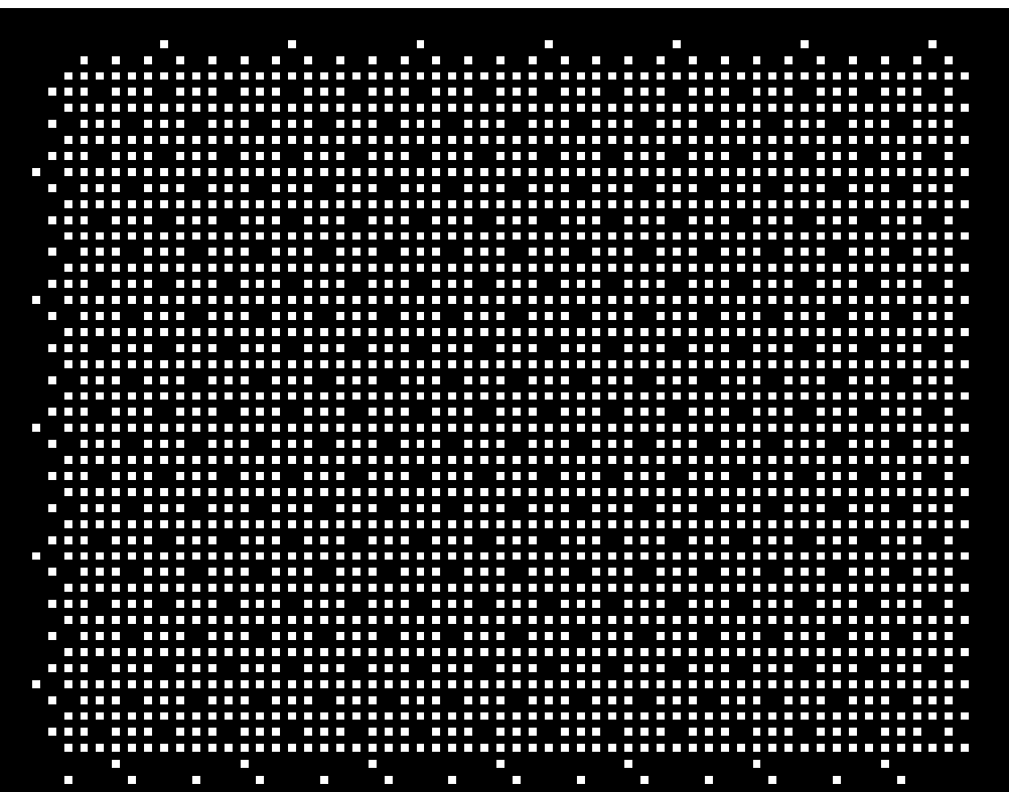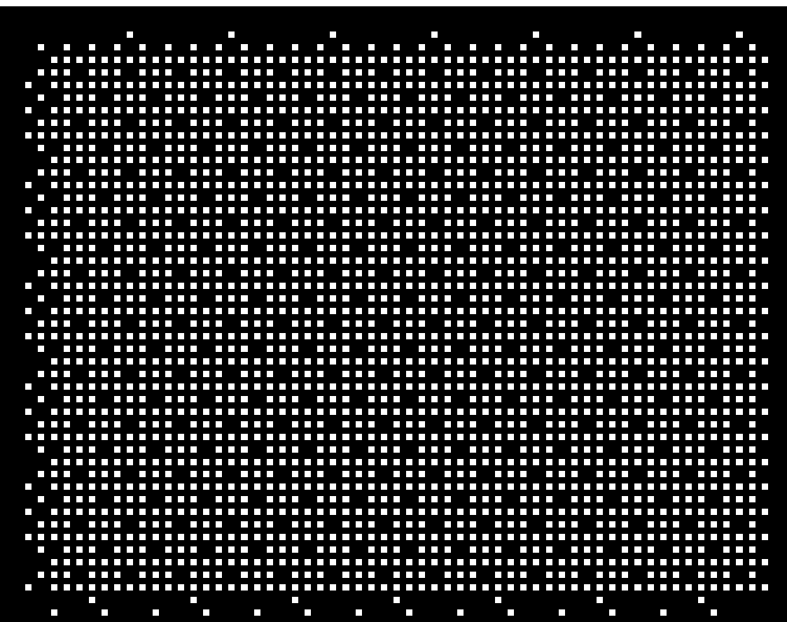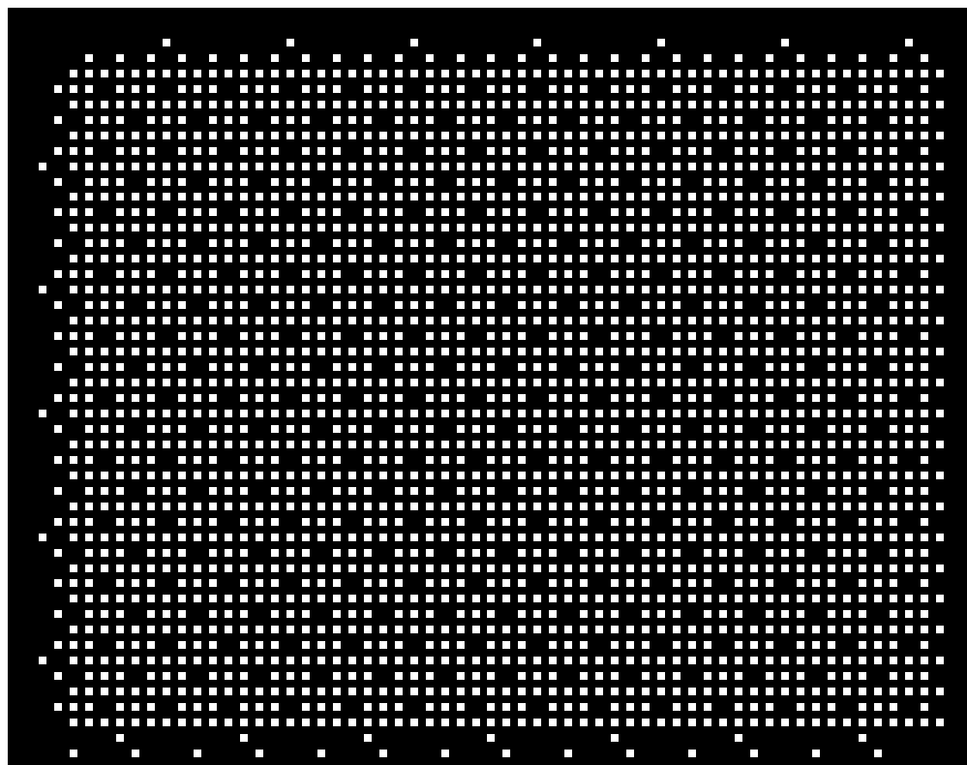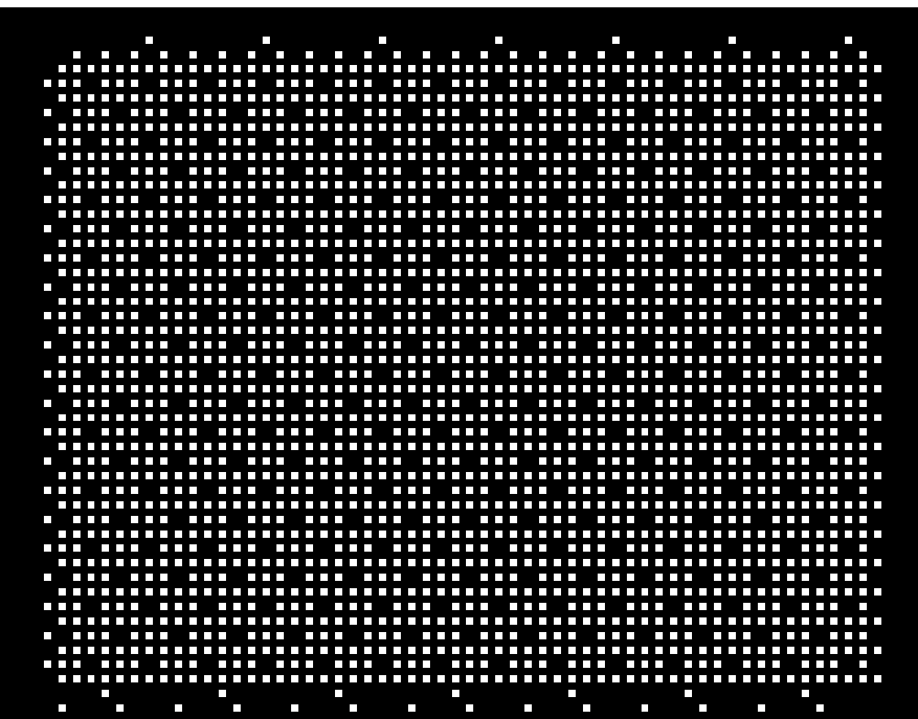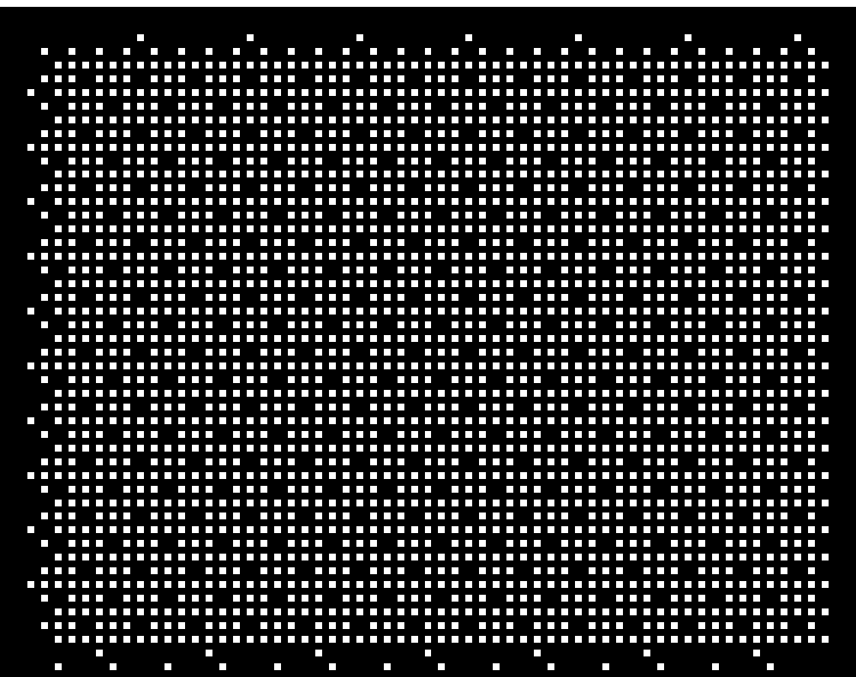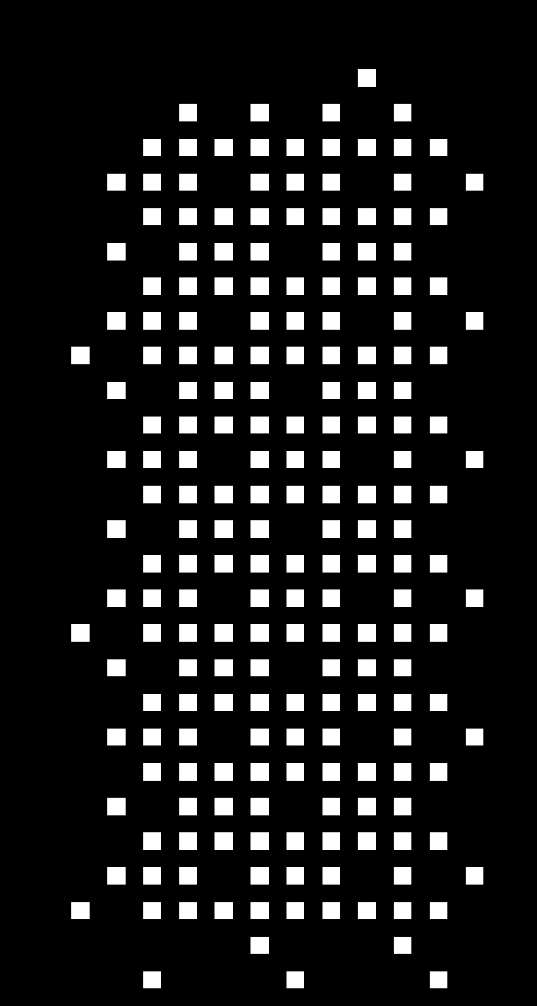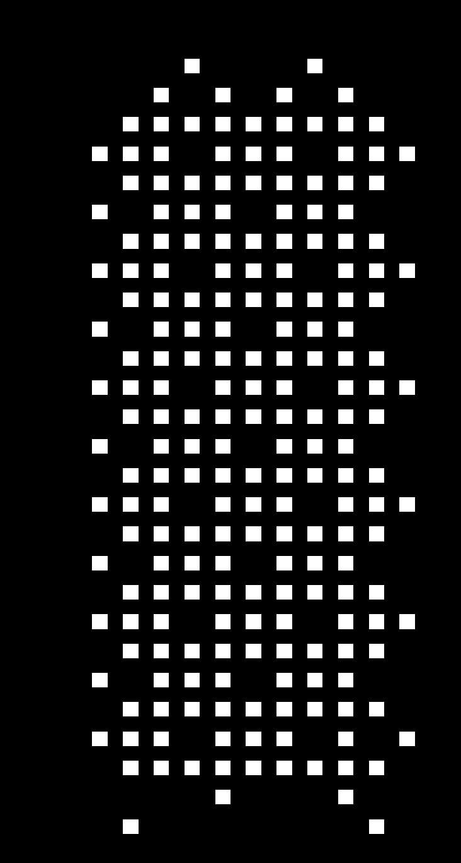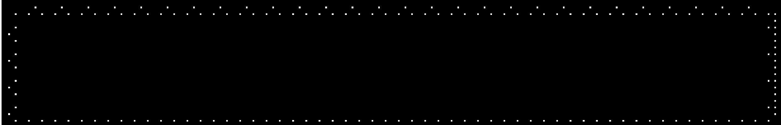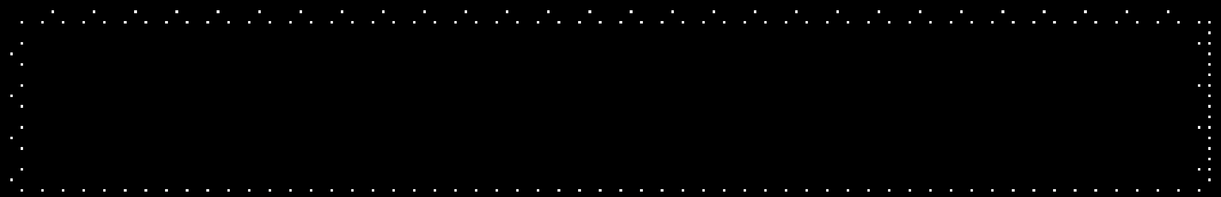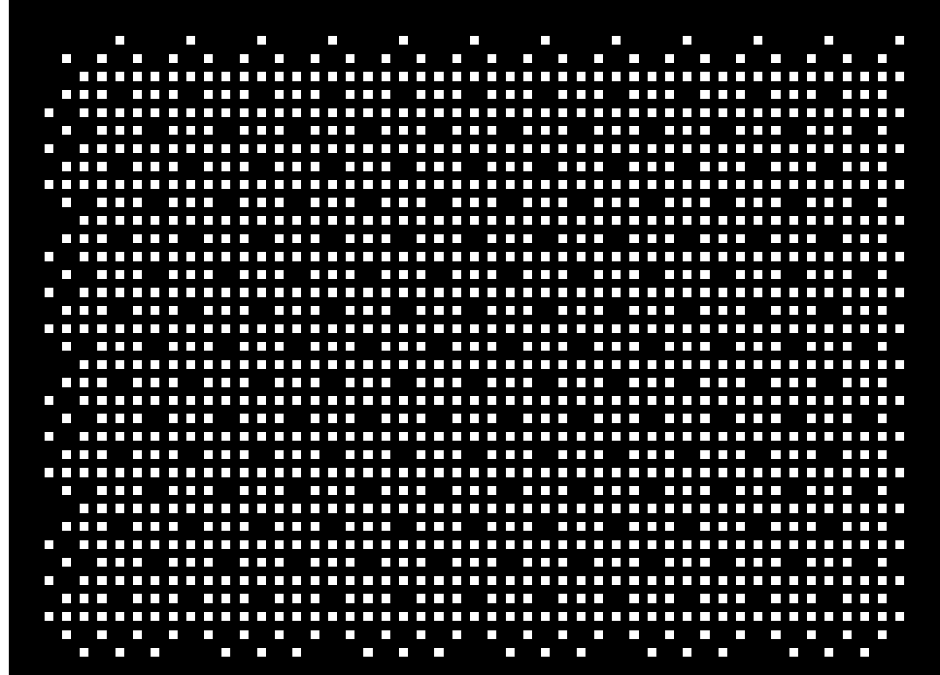

Half frame

(

5

ms

)

SS block

SS block

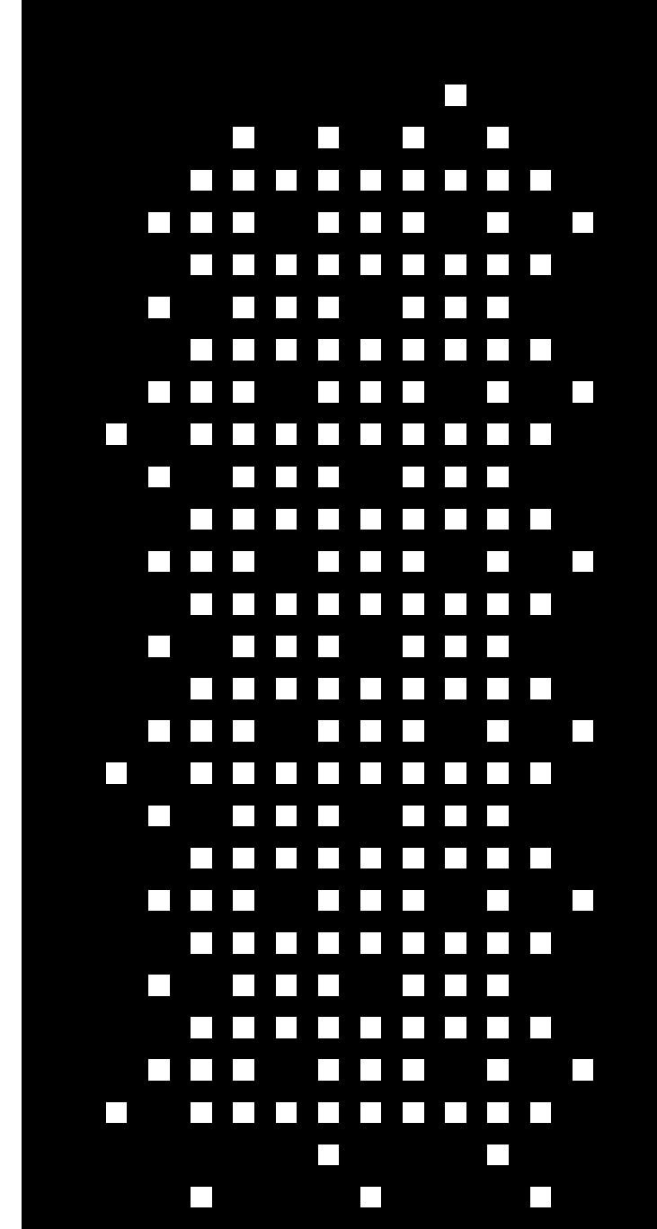

SS block

SS block

“SSB set”

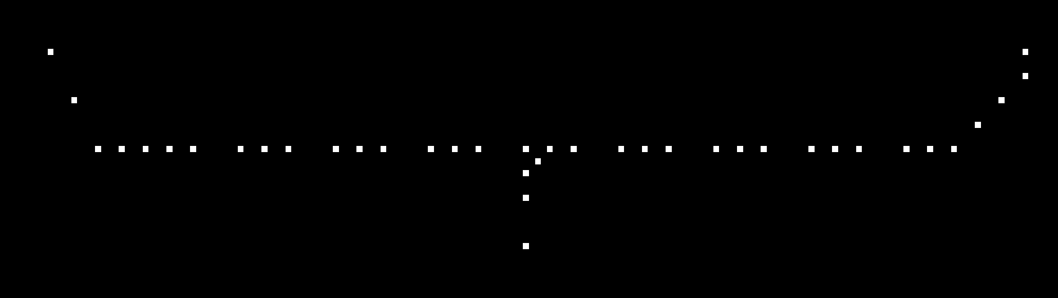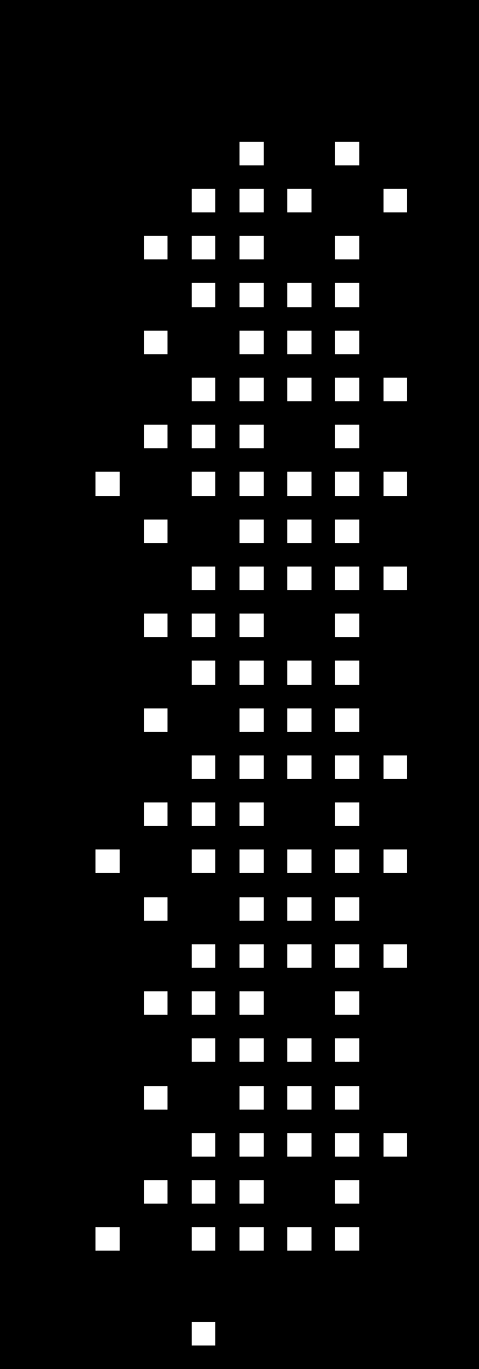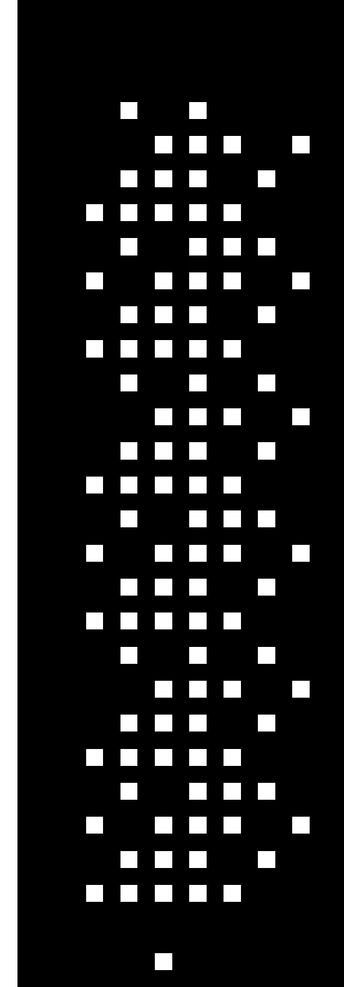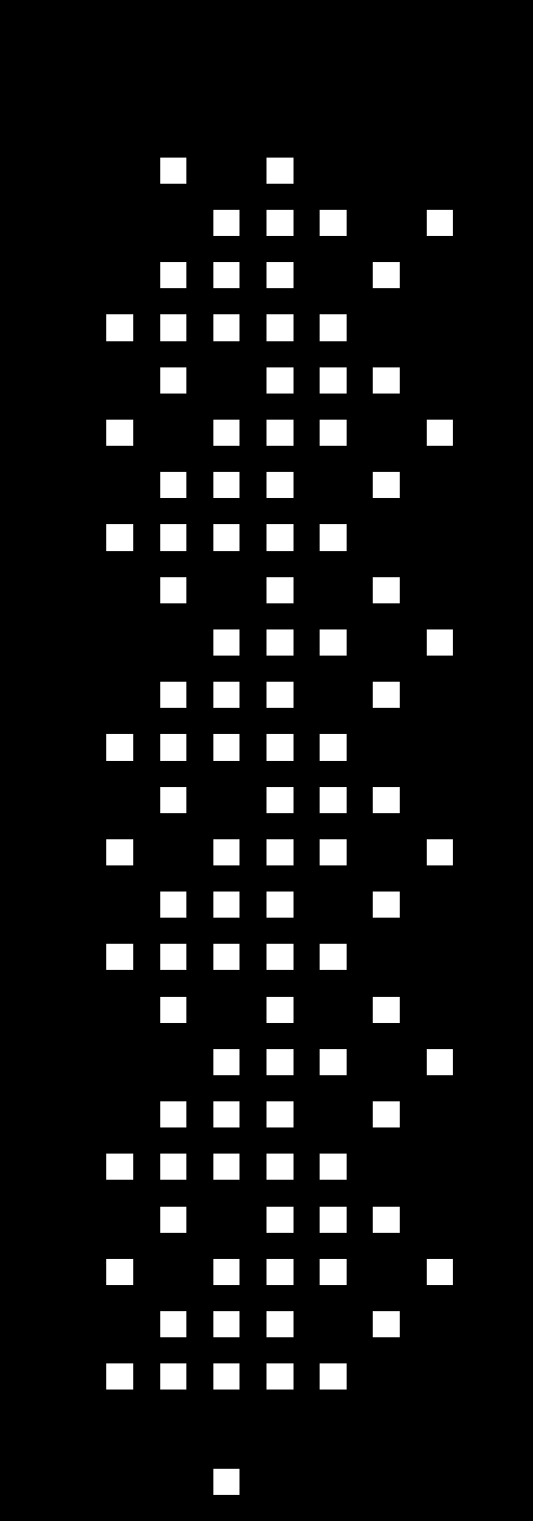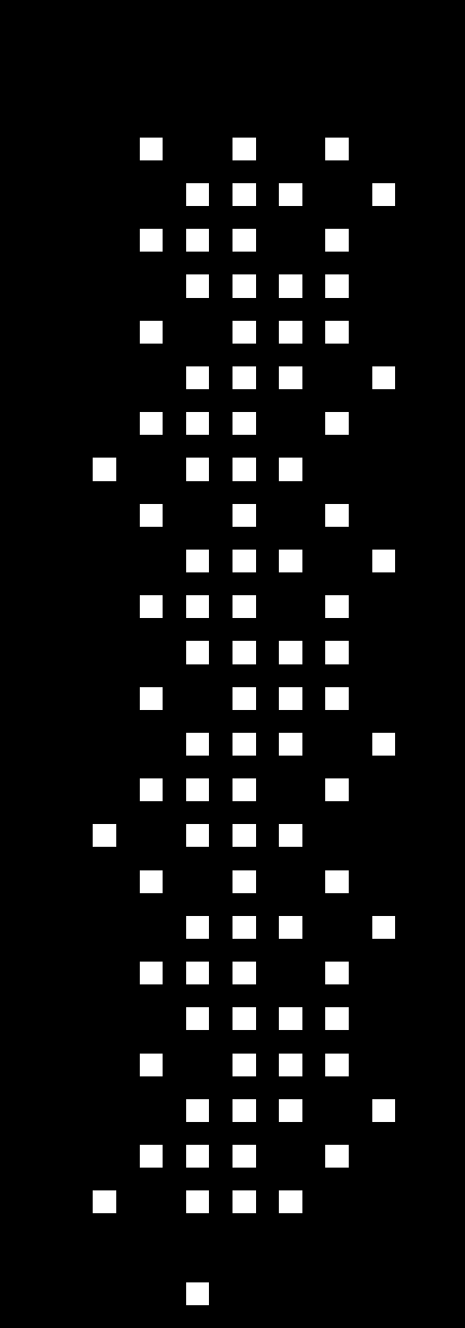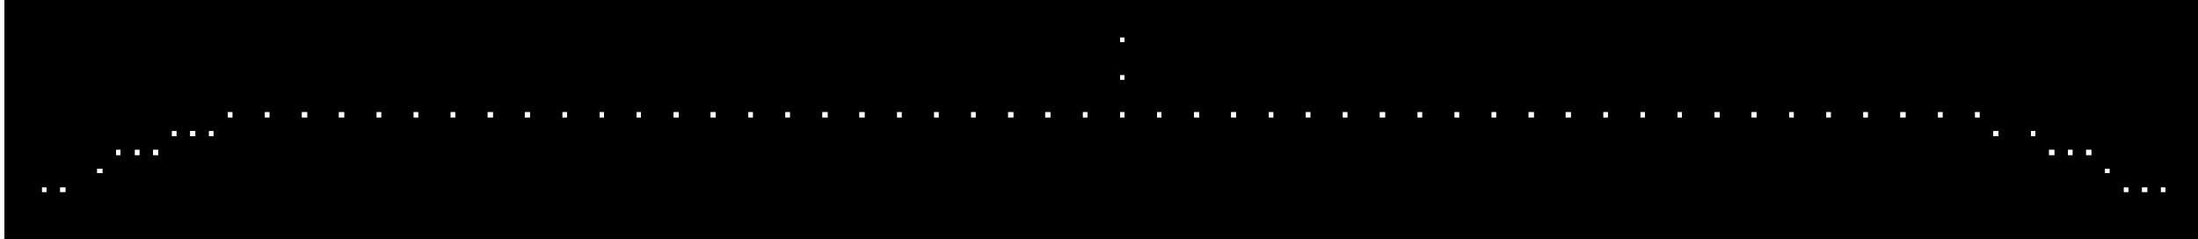

“SSB set”

periodicity

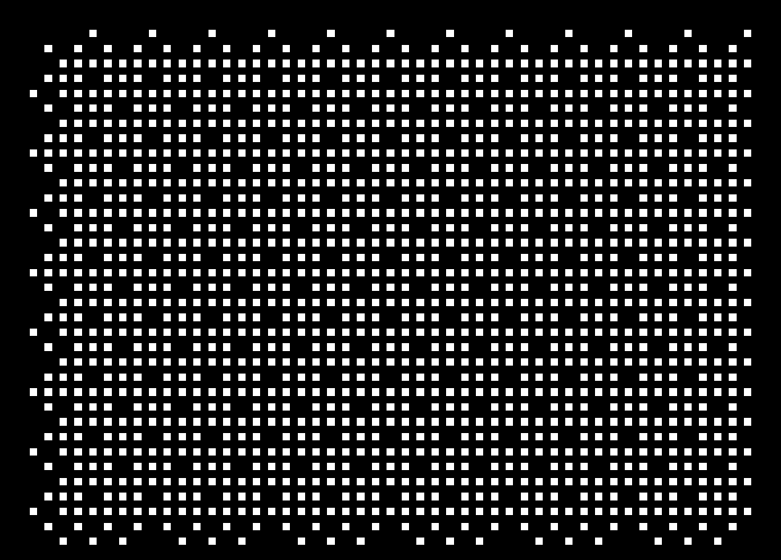

Half frame

(

5

ms

)

RMSI

RMSI

RMSI

RMSI

**Figure 7.1 Illustration of SS/PBCH block and RMSI transmission**

### Evaluation of sleep ratio

Based on the above mechanisms, the sleep ratio per slot basis and per symbol basis are given as follows,





where  indicates the ceiling of *x*,  is the numerology (as defined in T3.9038.211, e.g., *μ*=0 for 15 kHz SCS, *μ*=1 for 30 kHz SCS, *μ*=3 for 120 kHz SCS, and *μ*=4 for 240 kHz SCS), *L* is the number of SS/PBCH blocks in one SSB set, *P*SSB is the SSB set periodicity, *P*RMSI is the RSMI periodicity, and α is the flag variable (α=1 for FR1, and α=0 for FR2).

Evaluation results are shown in Table 7.1.1.1 and Table 7.1.1.2, respectively, for slot level and symbol level sleep ratio. It is observed that with SSB set period of 5ms, more than 80% of sleep ratio can be obtained by the network; with SSB set period of larger than 10ms, more than 90% of sleep ratio can be obtained by the network. Higher sleep ratio is expected with finer sleep granularity, e.g., in symbol level. Note that a subset of configurations in terms of number of SSB per set is used to derive the results.

Therefore, the network can achieve high sleep ratio in unloaded case.

**Table 7.1.1.1 Network sleep ratio in slot level**

|  |  |  |  |  |  |  |  |
| --- | --- | --- | --- | --- | --- | --- | --- |
| **SSB configuration** | | **SSB set periodicity** *P*SSB | | | | | |
| **SCS [kHz]** | **Number of SS/PBCH block per SSB set,** *L* | 5ms | 10ms | 20ms | 40ms | 80ms | 160ms |
| 15kHz | 1 | 80.00% | 90.00% | 95.00% | 97.50% | 98.75% | 99.38% |
| 2 | 80.00% | 90.00% | 95.00% | 97.50% | 98.75% | 99.38% |
| 30kHz | 1 | 95.00% | 97.50% | 98.75% | 99.38% | 99.69% | 99.84% |
| 4 | 80.00% | 90.00% | 95.00% | 97.50% | 98.75% | 99.38% |
| 120kHz | 8 | 90.00% | 95.00% | 97.50% | 98.75% | 99.38% | 99.69% |
| 16 | 80.00% | 90.00% | 95.00% | 97.50% | 98.75% | 99.38% |
| 240kHz | 16 | 90.00% | 95.00% | 97.50% | 98.75% | 99.38% | 99.69% |
| 32 | 80.00% | 90.00% | 95.00% | 97.50% | 98.75% | 99.38% |

**Table 7.1.1.2 Network sleep ratio in symbol level**

|  |  |  |  |  |  |  |  |
| --- | --- | --- | --- | --- | --- | --- | --- |
| **SSB configuration** | | **SSB set periodicity** *P*SSB | | | | | |
| **SCS [kHz]** | **Number of SS/PBCH block per SSB set,** *L* | 5ms | 10ms | 20ms | 40ms | 80ms | 160ms |
| 15kHz | 1 | 93.57% | 96.43% | 97.86% | 98.93% | 99.46% | 99.73% |
| 2 | 87.14% | 92.86% | 95.71% | 97.86% | 98.93% | 99.46% |
| 30kHz | 1 | 96.79% | 98.21% | 98.93% | 99.46% | 99.73% | 99.87% |
| 4 | 87.14% | 92.86% | 95.71% | 97.86% | 98.93% | 99.46% |
| 120kHz | 8 | 94.29% | 97.14% | 98.57% | 99.29% | 99.64% | 99.82% |
| 16 | 88.57% | 94.29% | 97.14% | 98.57% | 99.29% | 99.64% |
| 240kHz | 16 | 94.29% | 97.14% | 98.57% | 99.29% | 99.64% | 99.82% |
| 32 | 88.57% | 94.29% | 97.14% | 98.57% | 99.29% | 99.64% |

### Evaluation of sleep duration

Based on the above mechanisms, evaluation results of sleep duration is provided in Table 7.1.2.1 It is observed that with SSB set period of 160 ms, more than 150ms sleep duration can be obtained by network. Therefore, the network can achieve long sleep duration in unloaded case.

Therefore, the RIT meets network side energy efficiency requirement.

**Table 7.1.2.1 Network sleep duration (ms) in slot level**

|  |  |  |  |  |  |  |  |
| --- | --- | --- | --- | --- | --- | --- | --- |
| **SSB configuration** | | **SSB set periodicity** *P*SSB | | | | | |
| **SCS [kHz]** | **Number of SS/PBCH block per SSB set,** *L* | 5ms | 10ms | 20ms | 40ms | 80ms | 160ms |
| 15kHz | 1 | 4.00 | 9.00 | 19.00 | 39.00 | 79.00 | 159.00 |
| 2 | 4.00 | 9.00 | 19.00 | 39.00 | 79.00 | 159.00 |
| 30kHz | 1 | 4.50 | 9.50 | 19.50 | 39.50 | 79.50 | 159.50 |
| 4 | 4.00 | 9.00 | 19.00 | 39.00 | 79.00 | 159.00 |
| 120kHz | 8 | 4.50 | 9.72 | 18.92 | 39.03 | 78.97 | 158.99 |
| 16 | 4.00 | 9.88 | 18.77 | 39.05 | 78.96 | 158.99 |
| 240kHz | 16 | 4.50 | 9.86 | 18.90 | 39.04 | 78.97 | 158.99 |
| 32 | 4.00 | 9.94 | 18.76 | 39.06 | 78.96 | 158.99 |

## Device side

The sleep ratio and sleep duration for the UEs under unloaded case are evaluated.

DRX is supported for UEs in idle, inactive and connected states.

### Evaluation of sleep ratio

For idle state and inactive state, the UE should monitor one paging occasion per discontinuous reception (DRX) cycle (which equals to the paging cycle), and the UE can use DRX to reduce power consumption. Before paging receiving, the SSB monitoring is needed. Also RRM measurement(s), including intra- and inter-cell shall be performed.

The DRX cycle for idle state / inactive state UE consists of an “On Duration” during which the UE should perform SSB monitoring, paging monitoring and RRM measurement, and an “Off Duration” during which the UE can skip reception of downlink channels to save energy. It is illustrated in Figure 7.2.1.1.

Therefore, the sleep ratio is determined by the length of “On Duration” and the length of one paging cycle.

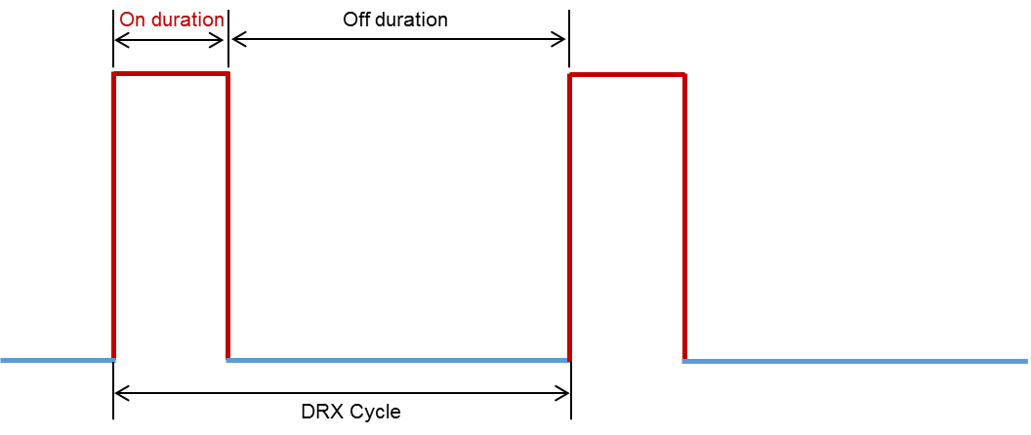

**Figure 7.2.1.1 Illustration of DRX cycle in connected state**

When DRX is used, the UE wakes up and receives SSB for synchronization, listens to PDCCH only on specific paging occasion defined in-terms of paging frame and subframe within period of *N*PC_RF radio frames defined by the DRX cycle (paging cycle) of the cell and performs RRM measurement. The UE can remain in sleep mode for remaining duration within DRX cycle.

For synchronization, one SSB-burst set is assumed for short paging cycle (e.g., 320ms). Further, it is assumed that synchronization signal can be located in the same slot as paging-on slot and UE can finish network synchronization before paging monitoring. For longer paging cycle, one SSB-burst can still be assumed. In addition, to improve synchronization accuracy, the case of two SSB-burst sets is also evaluated. In this case, UE needs additional time up to one SSB cycle for SSB reception.

For paging monitoring, a paging occasion *can consist of multiple time slots (e.g. slot or OFDM symbol) where* paging DCI can be sent. In the evaluation, it is assumed that one paging occasion consists of one slot. On the other hand, one paging cycle consists of one or multiple Paging Frames. One Paging Frame may contain one or multiple paging occasion(s) or starting point of a PO. In the evaluation, it is assumed that one Paging Frame contains one paging occasion and time for paging monitoring is not longer than that of one SSB burst.

RRM measurement is based on SS/PBCH. In the evaluation, it is assumed that RRM measurement takes place in “On Duration” time, and the RRM measurement time is assumed to be 3.5ms for FR2 and 3ms for FR1 (see [T3.9038.133]).

In addition to the above procedure, transition time is needed for UE to switch on / off its components. 10ms transition time is assumed for evaluation; but further reduced value is possible.

Based on the above analysis, the idle mode sleep ratio is evaluated with the configurations shown in Table 7.2.1.1. It is observed that more than 90% sleep ratio is achieved in idle mode by the device.

**Table 7.2.1.1 Device sleep ratio in slot level (for idle / inactive mode)**

|  |  |  |  |  |  |  |  |  |  |
| --- | --- | --- | --- | --- | --- | --- | --- | --- | --- |
|  | Paging cycle *N*PC_RF *10 (ms) | SCS(kHz) | SSB L | SSB reception time(ms) | SSB cycle (ms) | Number of SSB burst set | RRM measurement time per DRX (ms) | Transition time(ms) | Sleep ratio |
| RRC-Idle/Inactive | 320 | 240 | 32 | 1 | -- | 1 | 3.5 | 10 | 95.5% |
| 2560 | 15 | 2 | 1 | -- | 1 | 3 | 10 | 99.5% |
| 2560 | 15 | 2 | 1 | 160 | 2 | 3 | 10 | 93.2% |

Note: for SSB period,”--” is assumed that SSB reception is during DRX-On time.

For connected state, if there is no data transmission in either downlink or uplink direction, the DRX mode is switched on.

The DRX cycle for connected state UE consists of an “On Duration” during which the UE should perform SSB monitoring, PDCCH monitoring (reflected as *DRX-onDurationTimer*), and RRM measurement, and an “Off Duration” during which the UE can skip reception of downlink channels to save energy. Also, transition time is assumed in “On Duration”. The connected mode sleep ratio for different DRX cycles is shown in Table 7.2.1.2. Therefore the device can achieve high sleep ratio for both idle/inactive state and connected state in unloaded case.

**Table 7.2.1.2 Device sleep ratio in slot level (for connected mode)**

|  |  |  |  |  |  |  |
| --- | --- | --- | --- | --- | --- | --- |
|  | DRX cycle *T*SC_ms * *M*SC (ms) | Number of SSB burst set | DRX-onDurationTimer(ms) | RRM measurement time per DRX (ms) | Transition time(ms) | Sleep ratio |
| RRC-Connected | 320 | 1 | 2 | 3.5 | 10 | 95.2% |
| 320 | 1 | 10 | 3 | 10 | 92.8% |
| 2560 | 1 | 100 | 3 | 10 | 95.6% |
| 10240 | 1 | 1600 | 3 | 10 | 84.2% |

Note: for SSB period,”--” is assumed that SSB reception is during DRX-On time.

### Evaluation of sleep duration

The sleep duration for UE in idle mode is 2546ms for paging cycle of 2560ms with the assumed parameters.

The sleep duration of UE in connected state is 8627ms for paging cycle of 10240ms with the assumed parameters.

Consequently the device can achieve very long sleep duration in both idle mode and connected mode.

It is therefore concluded that the RIT meets device side energy efficiency requirement.

# Spectrum

As defined in Report ITU-R M.2411, spectrum requirement include

* The capability of being able to utilize at least one frequency band identified for IMT in the ITU Radio Regulations, and
* The capability of being able to utilize the higher frequency range/band(s) above 24.25 GHz (NOTE: In the case of the candidate SRIT, at least one of the component RITs need to fulfil this requirement.)

The bands in which the RIT can be deployed are given in Table 8.1 and Table 8.2 according to T3.9038.104 and T3.9036.101 (for MMTC). It is observed that the RIT can support at least one frequency band for IMT, as well as to utilize the higher frequency range/bands above 24.25 GHz. Therefore the RIT fulfils the spectrum requirement.

**Table** 8.**1: Operating bands in FR1**

|  |  |  |  |
| --- | --- | --- | --- |
| ***Operating band*** | **Uplink (UL) *operating band* BS receive / UE transmit**  **FUL_low – FUL_high** | **Downlink (DL) *operating band* BS transmit / UE receive**  **FDL_low – FDL_high** | **Duplex Mode** |
| n1 | 1920 MHz – 1980 MHz | 2110 MHz – 2170 MHz | FDD |
| n2 | 1850 MHz – 1910 MHz | 1930 MHz – 1990 MHz | FDD |
| n3 | 1710 MHz – 1785 MHz | 1805 MHz – 1880 MHz | FDD |
| n5 | 824 MHz – 849 MHz | 869 MHz – 894 MHz | FDD |
| n7 | 2500 MHz – 2570 MHz | 2620 MHz – 2690 MHz | FDD |
| n8 | 880 MHz – 915 MHz | 925 MHz – 960 MHz | FDD |
| n12 | 699 MHz – 716 MHz | 729 MHz – 746 MHz | FDD |
| n20 | 832 MHz – 862 MHz | 791 MHz – 821 MHz | FDD |
| n25 | 1850 MHz – 1915 MHz | 1930 MHz – 1995 MHz | FDD |
| n28 | 703 MHz – 748 MHz | 758 MHz – 803 MHz | FDD |
| n34 | 2010 MHz – 2025 MHz | 2010 MHz – 2025 MHz | TDD |
| n38 | 2570 MHz – 2620 MHz | 2570 MHz – 2620 MHz | TDD |
| n39 | 1880 MHz – 1920 MHz | 1880 MHz – 1920 MHz | TDD |
| n40 | 2300 MHz – 2400 MHz | 2300 MHz – 2400 MHz | TDD |
| n41 | 2496 MHz – 2690 MHz | 2496 MHz – 2690 MHz | TDD |
| n51 | 1427 MHz – 1432 MHz | 1427 MHz – 1432 MHz | TDD |
| n66 | 1710 MHz – 1780 MHz | 2110 MHz – 2200 MHz | FDD |
| n70 | 1695 MHz – 1710 MHz | 1995 MHz – 2020 MHz | FDD |
| n71 | 663 MHz – 698 MHz | 617 MHz – 652 MHz | FDD |
| n75 | N/A | 1432 MHz – 1517 MHz | SDL |
| n76 | N/A | 1427 MHz – 1432 MHz | SDL |
| n77 | 3300 MHz – 4200 MHz | 3300 MHz – 4200 MHz | TDD |
| n78 | 3300 MHz – 3800 MHz | 3300 MHz – 3800 MHz | TDD |
| n79 | 4400 MHz – 5000 MHz | 4400 MHz – 5000 MHz | TDD |
| n80 | 1710 MHz – 1785 MHz | N/A | SUL |
| n81 | 880 MHz – 915 MHz | N/A | SUL |
| n82 | 832 MHz – 862 MHz | N/A | SUL |
| n83 | 703 MHz – 748 MHz | N/A | SUL |
| n84 | 1920 MHz – 1980 MHz | N/A | SUL |
| n86 | 1710 MHz – 1780 MHz | N/A | SUL |

**Table 8.2: Operating bands in FR2**

|  |  |  |
| --- | --- | --- |
| ***operating band*** | **Uplink (UL) and Downlink (DL) *operating band* BS transmit/receive UE transmit/receive**  **FUL_low – FUL_high**  **FDL_low – FDL_high** | **Duplex Mode** |
| n257 | 26500 MHz – 29500 MHz | TDD |
| n258 | 24250 MHz – 27500 MHz | TDD |
| n260 | 37000 MHz – 40000 MHz | TDD |
| n261 | 27500 MHz – 28350 MHz | TDD |

MMTC operating bands

| Operating Band | | Uplink (UL) operating band BS receive UE transmit | | | | | Downlink (DL) operating band BS transmit  UE receive | | | | | Duplex Mode |
| --- | --- | --- | --- | --- | --- | --- | --- | --- | --- | --- | --- | --- |
| FUL_low – FUL_high | | | | | FDL_low – FDL_high | | | | |
| 1 | | 1920 MHz | | – | | 1980 MHz | 2110 MHz | | – | | 2170 MHz | HD-FDD |
| 2 | | 1850 MHz | | – | | 1910 MHz | 1930 MHz | | – | | 1990 MHz | HD-FDD |
| 3 | | 1710 MHz | | – | | 1785 MHz | 1805 MHz | | – | | 1880 MHz | HD-FDD |
| 4 | | 1710 MHz | | – | | 1755 MHz | 2110 MHz | | – | | 2155 MHz | HD-FDD |
| 5 | | 824 MHz | | – | | 849 MHz | 869 MHz | | – | | 894MHz | HD-FDD |
| 8 | | 880 MHz | | – | | 915 MHz | 925 MHz | | – | | 960 MHz | HD-FDD |
| 11 | | 1427.9 MHz | | – | | 1447.9 MHz | 1475.9 MHz | | – | | 1495.9 MHz | HD-FDD |
| 12 | | 699 MHz | | – | | 716 MHz | 729 MHz | | – | | 746 MHz | HD-FDD |
| 13 | | 777 MHz | | – | | 787 MHz | 746 MHz | | – | | 756 MHz | HD-FDD |
| 17 | | 704 MHz | | – | | 716 MHz | 734 MHz | | – | | 746 MHz | HD-FDD |
| 18 | | 815 MHz | | – | | 830 MHz | 860 MHz | | – | | 875 MHz | HD-FDD |
| 19 | | 830 MHz | | – | | 845 MHz | 875 MHz | | – | | 890 MHz | HD-FDD |
| 20 | | 832 MHz | | – | | 862 MHz | 791 MHz | | – | | 821 MHz | HD-FDD |
| 21 | | 1447.9 MHz | | – | | 1462.9 MHz | 1495.9 MHz | | – | | 1510.9 MHz | HD-FDD |
| 25 | | 1850 MHz | | – | | 1915 MHz | 1930 MHz | | – | | 1995 MHz | HD-FDD |
| 26 | | 814 MHz | | – | | 849 MHz | 859 MHz | | – | | 894 MHz | HD-FDD |
| 28 | | 703 MHz | | – | | 748 MHz | 758 MHz | | – | | 803 MHz | HD-FDD |
| 31 | | 452.5 MHz | | – | | 457.5 MHz | 462.5 MHz | | – | | 467.5 MHz | HD-FDD |
| 41 | | 2496 MHz | |  | | 2690 MHz | 2496 MHz | |  | | 2690 MHz | TDD |
| 66 | 1710 MHz | | – | | 1780 MHz | | 2110 MHz | – | | 2200 MHz | | HD-FDD |
| 70 | 1695 MHz | | – | | 1710 MHz | | 1995 MHz | – | | 2020 MHz | | HD-FDD |
| 71 | 663 MHz | | – | | 698 MHz | | 617 MHz | – | | 652 MHz | | HD-FDD |
| 72 | 451 MHz | | – | | 456 MHz | | 461 MHz | – | | 466 MHz | | HD-FDD |
| 74 | 1427 MHz | | – | | 1470 MHz | | 1475 MHz | – | | 1518 MHz | | HD-FDD |
| See details in Section 5.5F in [T3.9036.101]. These systems operate in HD-FDD or TDD mode | | | | | | | | | | | | |

# 5th Percentile User Spectral Efficiency

As defined in Report ITU-R M.2410, the 5th percentile user spectral efficiency is the 5% point of the CDF of the normalized user throughput. The normalized user throughput is defined as the number of correctly received bits, *i.e.,* the number of bits contained in the SDUs delivered to Layer 3, over a certain period of time, divided by the channel bandwidth and is measured in bit/s/Hz.

As required by Report ITU-R M.2412, 5th percentile user spectral efficiency shall be assessed jointly with average spectral efficiency using the same simulation. Therefore, the evaluation results of the 5th percentile user spectral efficiency are provided together with average spectral efficiency in Section 10.

# Average Spectral Efficiency

As defined in Report ITU-R M.2410, the average spectral efficiencyis the aggregate throughput of all users (the number of correctly received bits, *i.e.,* the number of bits contained in the SDUs delivered to Layer 3, over a certain period of time) divided by the channel bandwidth of a specific band divided by the number of TRxPs and is measured in bit/s/Hz/TRxP. As required by Report ITU-R M.2412, the average spectral efficiency and the 5th percentile user spectral efficiency are assessed jointly using the same simulation.

A wide range of antenna configurations and transmission schemes are considered.

The antenna configuration is indicated as (*M*, *N*, *P*, *M*g,*N*g; *M*p, *N*p), where *M* and *N* are the number of vertical, horizontal antenna elements within a panel, *P* is number of polarizations, *M*g is the number of panels in a column, *N*g is the number of panels in row; and *M*p and *N*p are the number of vertical, horizontal TXRUs within a panel and polarization.

## Indoor Hotspot

The RIT was evaluated for Configuration A, *i.e.,* a carrier frequency of 4 GHz for both FDD and TDD. In the following table, important simulation parameters used for the simulation are highlighted. More details and additional parameters used in the simulation can be found in the excel sheets attached in Section 21.

|  |  |
| --- | --- |
| Simulation parameters | As per ITU-R M.2412 |
| Configuration | A (4 GHz) |
| Channel Model | B |
| Bandwidth | FDD: 10 MHz TDD: 20 MHz |
| Duplexing | TDD/FDD |
| TDD Frame Structure | DSUUD |
| Sub-Carrier-Spacing (SCS) | 15 kHz |
| MIMO configuration | 32 X 4 |
| gNB antenna configuration | (M,N,P,Mg,Ng; Mp,Np) = (4,4,2,1,1;4,4) |
| UE antenna configuration | (M,N,P,Mg,Ng; Mp,Np) = (1,2,2,1,1; 1,2) |
| UE power class | 23 dBm |
| Downlink | TDD: 32x4 MU-MIMO |
| FDD: 32x4 MU-MIMO |
| Uplink | TDD: 4x32 SU-MIMO, Codebook based, OFDMA |
| FDD: 4x32 SU-MIMO , OFDMA |
| TRXP | 12 |

The average and the 5th -percentile spectral efficiencies are provided in Table 10.1.1 and Table 10.1.2 for TDD and FDD configurations respectively.

**Table 10.1.1: Average and 5th-percentile spectral efficiency for TDD configuration for the Indoor hotspot test environment for 20 MHz**

|  |  |  |  |
| --- | --- | --- | --- |
|  |  | ITU Requirement | Achieved |
| Downlink | Average [bit/s/Hz/TRxP] | 9 | 9.94 |
| 5th-tile [bit/s/Hz] | 0.3 | 0.32 |
| Uplink | Average [bit/s/Hz/TRxP] | 6.75 | 8.03 |
| 5th-tile [bit/s/Hz] | 0.21 | 0.33 |

**Table 10.1.2: Average and 5th-percentile spectral efficiency for FDD configuration for the Indoor hotspot test environment for 10 MHz for downlink and 10 MHz for uplink**

|  |  |  |  |
| --- | --- | --- | --- |
|  |  | ITU Requirement | Achieved |
| Downlink | Average [bit/s/Hz/TRxP] | 9 | 10.02 |
| 5th-tile [bit/s/Hz] | 0.3 | 0.32 |
| Uplink | Average [bit/s/Hz/TRxP] | 6.75 | 8.47 |
| 5th-tile [bit/s/Hz] | 0.21 | 0.34 |

It is observed that the RIT fulfils the UL and DL average and the 5th percentile spectral efficiency requirement for the Indoor hotspot test environment.

For higher bandwidths, the overhead decreases increasing the effective spectral efficiency by a scaling factor. The overhead details and the scaling factors are provided in Section 21.a. These results will be used for computing the Area Traffic Capacity.

## Dense Urban

The RIT was evaluated for Configuration A, *i.e.,* a carrier frequency of 4 GHz for both FDD and TDD. In the following table, important simulation parameters used for the simulation are highlighted. More details and additional parameters used in the simulation can be found in the excel sheets attached in Section 21.

|  |  |
| --- | --- |
| Simulation parameters | As per ITU-R M.2412 |
| Configuration | A (4 GHz) |
| Channel Model | B |
| Bandwidth | FDD: 10 MHz TDD: 20 MHz |
| Duplexing | TDD/FDD |
| TDD frame structure | DSUUD |
| SCS | 15 kHz |
| MIMO configuration | 32 X 4 |
| gNB antenna configuration | (M,N,P,Mg,Ng; Mp,Np) = (8,8,2,1,1;2,8) |
| UE antenna configuration | (M,N,P,Mg,Ng; Mp,Np) = (1,2,2,1,1; 1,2) |
| UE power class | 23 dBm |
| Downlink | TDD: 32x4 MU-MIMO |
| FDD: 32x4 MU-MIMO |
| Uplink | TDD: 4x32 SU-MIMO, Codebook based, OFDMA |
| FDD: 4x32 SU-MIMO , OFDMA |

The average and the 5th -percentile spectral efficiencies are provided in Table 10.2.1 and Table 10.2.2 for TDD and FDD configurations respectively.

**Table 10.2.1: Average and 5th-percentile spectral efficiency for TDD configuration for the Dense Urban test environment**

|  |  |  |  |
| --- | --- | --- | --- |
|  |  | ITU Requirement | Achieved |
| Downlink | Average [bit/s/Hz/TRxP] | 7.8 | 12.65 |
| 5th-tile [bit/s/Hz] | 0.225 | 0.28 |
| Uplink | Average [bit/s/Hz/TRxP] | 5.4 | 6.63 |
| 5th-tile [bit/s/Hz] | 0.15 | 0.18 |

**Table 10.2.2: Average and 5th-percentile spectral efficiency for FDD configuration for the Dense Urban test environment**

|  |  |  |  |
| --- | --- | --- | --- |
|  |  | ITU Requirement | Achieved |
| Downlink | Average [bit/s/Hz/TRxP] | 7.8 | 13.09 |
| 5th-tile [bit/s/Hz] | 0.225 | 0.34 |
| Uplink | Average [bit/s/Hz/TRxP] | 5.4 | 7.26 |
| 5th-tile [bit/s/Hz] | 0.15 | 0.22 |

It is observed that the RIT fulfils the UL and DL average and the 5th percentile spectral efficiency requirement for the Dense Urban test environment.

For higher bandwidths, the overhead decreases increasing the effective spectral efficiency by a scaling factor. The overhead details and the scaling factors are provided in Section 21.b. These results will be used for computing the User Experienced Data Rate.

## Rural e-MBB

The Rural e-MBB test environment was evaluated for all the configurations.

### Configuration A (700 MHz)

The RIT was evaluated for Rural e-MBB Configuration A, i.e., a carrier frequency of 700 MH z for both FDD and TDD. In the following table, important simulation parameters used for the simulation are highlighted. More details and additional parameters used in the simulation can be found in the excel sheets attached in Section 21.

|  |  |
| --- | --- |
| Simulation parameters | As per ITU-R M.2412 |
| Configuration | A (700 MHz) |
| Channel Model | B |
| Bandwidth | FDD: 10 MHz TDD: 20 MHz |
| Duplexing | TDD/FDD |
| TDD frame structure | DSUUD |
| SCS | 15 kHz |
| MIMO configuration | 8 x 2 |
| gNB antenna configuration | (M,N,P,Mg,Ng; Mp,Np) = (8,4,2,1,1;1,4) |
| UE antenna configuration | (M,N,P,Mg,Ng; Mp,Np) = (1,1,2,1,1; 1,1) |
| UE power class | 23 dBm |
| Downlink | TDD: 8x2 MU-MIMO, |
| FDD: 8x2 MU-MIMO |
| Uplink | TDD: 2x8 SU-MIMO, Codebook based, OFDMA, |
| FDD: 2x8 SU-MIMO , OFDMA |

The average and the 5th -percentile spectral efficiencies are provided in Table 10.3.1.1 and Table 10.3.1.2 for TDD and FDD configurations respectively.

**Table 10.3.1.1: Average and 5th-percentile spectral efficiency for TDD configuration for the Rural-eMBB test environment, Configuration A (700 MHz)**

|  |  |  |  |
| --- | --- | --- | --- |
|  |  | ITU Requirement | Achieved |
| Downlink | Average [bit/s/Hz/TRxP] | 3.3 | 6.05 |
| 5th-tile [bit/s/Hz] | 0.12 | 0.16 |
| Uplink | Average [bit/s/Hz/TRxP] | 1.6 | 4.62 |
| 5th-tile [bit/s/Hz] | 0.045 | 0.1 |

**Table 10.3.1.2: Average and 5th-percentile spectral efficiency for FDD configuration for the Rural-eMBB test environment, Configuration A (700 MHz)**

|  |  |  |  |
| --- | --- | --- | --- |
|  |  | ITU Requirement | Achieved |
| Downlink | Average [bit/s/Hz/TRxP] | 3.3 | 6.49 |
| 5th-tile [bit/s/Hz] | 0.12 | 0.17 |
| Uplink | Average [bit/s/Hz/TRxP] | 1.6 | 5.71 |
| 5th-tile [bit/s/Hz] | 0.045 | 0.19 |

### Configuration B (4 GHz)

The RIT was evaluated for Rural e-MBB Configuration B, i.e., a carrier frequency of 4 GHz for both FDD and TDD. The following simulation parameters were used for the evaluation.

|  |  |
| --- | --- |
| Simulation parameters | As per ITU-R M.2412 |
| Configuration | B (4 GHz) |
| Channel Model | B |
| Bandwidth | FDD: 10 MHz TDD: 20 MHz |
| Duplexing | TDD/FDD |
| TDD Frame Structure | DSUUD |
| SCS | 15 kHz |
| MIMO configuration | 32 X 4 |
| gNB antenna configuration | (M,N,P,Mg,Ng; Mp,Np) = (8,8,2,1,1;2,8) |
| UE antenna configuration | (M,N,P,Mg,Ng; Mp,Np)= (1,2,2,1,1; 1,2) |
| UE power class | 23 dBm |
| Downlink | TDD: 32x4 MU-MIMO |
| FDD: 32x4 MU-MIMO |
| Uplink | TDD: 4x32 SU-MIMO, Codebook based, OFDMA |
| FDD: 4x32 SU-MIMO , OFDMA |

The average and the 5th -percentile spectral efficiencies are provided in Table 10.3.2.1 and Table 10.3.2.2 for TDD and FDD configurations respectively.

**Table 10.3.2.1: Average and 5th-percentile spectral efficiency for TDD configuration for the Rural-eMBB test environment, Configuration B (4 GHz)**

|  |  |  |  |
| --- | --- | --- | --- |
|  |  | ITU Requirement | Achieved |
| Downlink | Average [bit/s/Hz/TRxP] | 3.3 | 14.74 |
| 5th-tile [bit/s/Hz] | 0.12 | 0.34 |
| Uplink | Average [bit/s/Hz/TRxP] | 1.6 | 5.06 |
| 5th-tile [bit/s/Hz] | 0.045 | 0.05 |

**Table 10.3.2.2: Average and 5th-percentile spectral efficiency for FDD configuration for the Rural-eMBB test environment, Configuration B (4 GHz)**

|  |  |  |  |
| --- | --- | --- | --- |
|  |  | ITU Requirement | Achieved |
| Downlink | Average [bit/s/Hz/TRxP] | 3.3 | 14.85 |
| 5th-tile [bit/s/Hz] | 0.12 | 0.33 |
| Uplink | Average [bit/s/Hz/TRxP] | 1.6 | 5.51 |
| 5th-tile [bit/s/Hz] | 0.045 | 0.05 |

### LMLC (700 MHz)

The RIT was evaluated for Rural e-MBB LMLC configuration for both FDD and TDD. The following simulation parameters were used for the evaluation.

|  |  |
| --- | --- |
| Simulation parameters | As per ITU-R M.2412 |
| Configuration | LMLC (700 MHz) |
| Channel Model | B |
| Bandwidth | FDD: 10 MHz TDD: 20 MHz |
| Duplexing | TDD/FDD |
| TDD Frame Structure | DSUUD |
| SCS | 15 kHz |
| MIMO configuration | 8 X 4 |
| gNB antenna configuration | (M,N,P,Mg,Ng; Mp,Np) = (8,4,2,1,1;1,4) |
| UE antenna configuration | (M,N,P,Mg,Ng; Mp,Np) = (1,2,2,1,1; 1,2) |
| UE power class | 23 dBm |
| Downlink | TDD: 8x4 MU-MIMO |
| FDD: 8x4 MU-MIMO |
| Uplink | TDD: 4x8 SU-MIMO, Codebook based, OFDMA |
| FDD: 4x8 SU-MIMO , OFDMA |

The average and the 5th -percentile spectral efficiencies are provided in Table 10.3.3.1 and Table 10.3.3.2 for TDD and FDD configurations respectively.

**Table 10.3.3.1: Average and 5th-percentile spectral efficiency for TDD configuration for the Rural-eMBB test environment, LMLC Configuration**

|  |  |  |  |
| --- | --- | --- | --- |
|  |  | ITU Requirement | Achieved |
| Downlink | Average [bit/s/Hz/TRxP] | 3.3 | 8.14 |
| 5th-tile [bit/s/Hz] | 0.12 | 0.29 |
| Uplink | Average [bit/s/Hz/TRxP] | 1.6 | 2.75 |
| 5th-tile [bit/s/Hz] | 0.045 | 0.05 |

**Table 10.3.3.2: Average and 5th-percentile spectral efficiency for FDD configuration for the Rural-eMBB test environment, LMLC Configuration**

|  |  |  |  |
| --- | --- | --- | --- |
|  |  | ITU Requirement | Achieved |
| Downlink | Average [bit/s/Hz/TRxP] | 3.3 | 8.47 |
| 5th-tile [bit/s/Hz] | 0.12 | 0.24 |
| Uplink | Average [bit/s/Hz/TRxP] | 1.6 | 3.37 |
| 5th-tile [bit/s/Hz] | 0.045 | 0.05 |

It is observed that the RIT fulfils the UL and DL average and the 5th percentile spectral efficiency requirement for the Rural e-MBB test environment for all the three configurations.

# User Experienced Data Rate

As defined in Report ITU-R M.2410, user experienced data rate is the 5% point of the cumulative distribution function (CDF) of the user throughput. User throughput (during active time) is defined as the number of correctly received bits, i.e. the number of bits contained in the service data units (SDUs) delivered to Layer 3, over a certain period of time.

The user experienced data rate, Ruser is given by:

Ruser = W × SEuser

In case bandwidth is aggregated across multiple bands (one or more TRxP layers), the user experienced data rate will be summed over the bands. We use the SEuser reported in Section 10 for the evaluation for the Dense Urban-eMBB test environment Configuration A and the above formula.

It is assumed that for TDD with 15 kHz SCS, a component carrier with 50 MHz is used. It is assumed that for FDD with 15kHz, a component carrier with 40 MHz is used. For higher bandwidths, the overhead decreases increasing the effective spectral efficiency by a scaling factor for the downlink. The overhead details and the scaling factors are provided in Section 21.a. Multiple component carriers are aggregated to achieve the DL target user experienced data rate. The assumed DL/UL aggregated system bandwidth (for FDD) or overall aggregated system bandwidth (for TDD) and other assumptions are given in Table 11.1 for TDD and Table 11.2 for FDD

Table 11.1 User experienced data rate in Dense Urban – eMBB for TDD configuration

|  |  |  |  |  |
| --- | --- | --- | --- | --- |
| Scheme | Assumed Bandwidth  W | 5-percentile SE  SEuser | User Experienced Data Rate  Ruser = W × SEuser | ITU Requirement |
| Downlink, TDD (DSUUD) | 800 MHz | 0.331 | 148.4 Mbps | 100 Mbps |
| Uplink, TDD  (DSUUD) | 800 MHz | 0.18 | 63.36 Mbps | 50 Mbps |

Footnote: 10.33 = 0.28 x 1.18, where 0.28 bps/Hz is the 5% SE for the downlink provided in Section 10.2 and 1.18 is the overhead scaling factor given in Section 21.b. We have considered 16 component carriers (CC) of 50 MHz each.

Table 11.2 User experienced data rate Dense Urban – eMBB for FDD configuration

|  |  |  |  |  |
| --- | --- | --- | --- | --- |
| Scheme | Assumed Bandwidth  W | 5-percentile SE  SEuser | User Experienced Data Rate  Ruser = W × SEuser | ITU Requirement |
| Downlink, FDD | 400 MHz | 0.411 | 164 Mbps | 100 Mbps |
| Uplink, FDD | 400 MHz | 0.22 | 88 Mbps | 50 Mbps |

*0.41 = 0.34x1.216, where 0.34 bps/Hz is the 5% SE for the downlink provided in Section 10.2 and 1.216 is the overhead scaling factor given in Section 21.b. We have considered 10 CC of 40 MHz each.

It is observed that the RIT can fulfil UL user experienced data rate requirement for Dense Urban eMBB test environment.

# Area Traffic Capacity

As defined in Report ITU-R M.2410, area traffic capacity is the total traffic throughput served per geographic area (in Mbit/s/m2). The throughput is the number of correctly received bits, i.e. the number of bits contained in the SDUs delivered to Layer 3, over a certain period of time.

The area traffic capacity of the RIT is evaluated using analytical way based on the downlink average spectral efficiency evaluation for Indoor Hotspot – eMBB test environment. Let W denote the channel bandwidth and the TRxP density (TRxP/m2). The area traffic capacity Carea is related to average spectral efficiency SEavg through equation Carea = ρ × W × SEavg.

Table 12.1 Area Traffic Capacity – In-H for the TDD configuration for 12 TRXP

|  |  |  |  |  |  |
| --- | --- | --- | --- | --- | --- |
| Scheme | Assumed Bandwidth W | Avg. SE SEavg | TRxP density (TRxP/m2)  ρ | Area traffic capacity  Carea = ρ × W × SEavg Mbit/s/m2 | ITU Requirement  Mbit/s/m2 |
| Downlink, TDD | 800 MHz | 11.731 | 0.002 = 12/(120x50) | 10.51 | 10 |

Footnote: 111.73=9.9 x 1.18, where 9.9 bps/Hz is the Avg SE for the downlink provided in Section 10.1 and 1.18 is the overhead scaling factor given in Section 21.a. We have considered 16 component carriers (CC) of 50 MHz each.

Table 12.2 Area Traffic Capacity – In-H for the FDD configuration for 12 TRXP

|  |  |  |  |  |  |
| --- | --- | --- | --- | --- | --- |
| Scheme | Assumed Bandwidth W | Avg. SE SEavg | TRxP density (TRxP/m2)  ρ | Area traffic capcity  Carea = ρ × W × SEavg Mbit/s/m2 | ITU Requirement  Mbit/s/m2 |
| Downlink, FDD | 480 MHz | 12.184 | 0.002 | 11.70 | 10 |

Footnote:1 12.184 = 10.02 x 1.216, where 10.02 bps/Hz is the Avg SE for the downlink provided in Section 10.1 and 1.216 is the overhead scaling factor given in Section 21.a. We have considered 12 component carriers (CC) of 40 MHz each.

It is assumed that for TDD with 15 kHz SCS, a component carrier with 50 MHz is used. It is assumed that for FDD with 15kHz, a component carrier with 40 MHz is used. Multiple component carriers are aggregated to achieve the DL target user experienced data rate. The assumed aggregated system bandwidth is given in Tables 12.1 and 12.2.

It is observed that both FDD and TDD fulfil the area traffic capacity requirement in evaluation configuration A.

# Mobility

As defined in Report ITU-R M.2410, Mobility is the maximum mobile station speed at which a defined QoS can be achieved (in km/h). The QoS is defined as normalized traffic channel link data rate. The simulation parameters used can be found in the excel sheets attached in Section 21.b. Channel model B is used for all the Mobility evaluations.

## Indoor Hotspot – eMBB

Evaluation configuration A (carrier frequency = 4 GHz) are applied for the evaluations of Indoor Hotspot – eMBB test environment.

**Table 13.1.1 Mobility in Indoor Hotspot– eMBB for Configuration A with 12 TRXP**

|  |  |  |  |  |  |  |
| --- | --- | --- | --- | --- | --- | --- |
| Schema | Duplexing  Scheme | Mobility | Sub-carrier spacing (kHz) | Channel | ITU Requirement  Bits/Hz | Normalized traffic channel link data rate (bit/s/Hz) |
| 1x32 SIMO, OFDMA | FDD | 10Km/h | 15 KHz SCS | NLOS | 1.5 | 2.61 |

It is observed that the RIT fulfils the mobility requirement in evaluation configuration A.

## Dense Urban – eMBB

Evaluation configuration A (carrier frequency = 4 GHz) are applied for the evaluations of Dense Urban – eMBB test environment.

|  |  |  |  |  |  |  |
| --- | --- | --- | --- | --- | --- | --- |
| Schema | Duplexing  Scheme | Mobility | Sub-carrier spacing (kHz) | Channel | ITU Requirement  Bits/Hz | Normalized traffic channel link data rate (bit/s/Hz) |
| 1x8 SIMO, OFDMA | FDD | 30Km/h | 15 KHz SCS | NLOS | 1.2 | 2.8 |

It is observed that the RIT fulfils the mobility requirement in evaluation configuration A.

## Rural-eMBB

The evaluation results of mobility for FDD and TDD for evaluation configuration A for mobility class of 120 Kmph and 500 Kmph are provided in Table 13.3.1 for Configuration A of Rural eMBB and for Configuration B in Table 13.3.2

**Table 13.3.1 Mobility in Rural – eMBB for Configuration A (700 MHz)**

|  |  |  |  |  |  |  |
| --- | --- | --- | --- | --- | --- | --- |
| Schema | Duplexing  Scheme | Mobility | Sub-carrier spacing (kHz) | Channel | ITU Requirement  Bits/Hz | Normalized traffic channel link data rate (bit/s/Hz) |
| 1x4 SIMO, OFDMA | FDD | 120Km/h | 15 KHz SCS | NLOS | 0.8 | 2.65 |
| 1x4 SIMO, OFDMA | FDD | 500Km/h | 15 KHz SCS | NLOS | 0.45 | 2.52 |

**Table 13.3.2 Mobility in Rural – eMBB for Configuration B (4GHz)**

|  |  |  |  |  |  |  |
| --- | --- | --- | --- | --- | --- | --- |
| Schema | Duplexing  Scheme | Mobility | Sub-carrier spacing (kHz) | Channel | ITU Requirement  Bits/Hz | Normalized traffic channel link data rate (bit/s/Hz) |
| 1x8 SIMO, OFDMA | FDD | 120Km/h | 15 KHz SCS | NLOS | 0.8 | 2.91 |
| 1x8 SIMO, OFDMA | FDD | 500Km/h | 15 KHz SCS | NLOS | 0.45 | 2.72 |

It is observed that RIT fulfils the mobility requirement under both 120km/h and 500km/h.

# Reliability

As defined in Report ITU-R M.2412, reliability is the success probability of transmitting a layer 2/3 packet within a required maximum time, which is the time it takes to deliver a small data packet from the radio protocol layer 2/3 SDU ingress point to the radio protocol layer 2/3 SDU egress point of the radio interface at a certain channel quality.

Reliability is evaluated under Urban Macro – URLLC test environment. Both downlink and uplink are evaluated. A variety of configurations are considered.

## DL reliability

For downlink reliability, both evaluation configuration A (carrier frequency = 4 GHz) and evaluation configuration B (carrier frequency = 700 MHz) are evaluated. The evaluation results of FDD for downlink reliability are provided in Table 14.1.1. All the evaluation results are derived for evaluation configuration A (CF = 4 GHz) and B (CF = 700 MHz), respectively. It is observed that FDD fulfils the reliability requirement for downlink in a wide range of configurations.

**Table 14.1.1 Evaluation results of downlink reliability for FDD**

1. **Evaluation configuration A (CF = 4 GHz)**

|  |  |  |  |  |  |
| --- | --- | --- | --- | --- | --- |
| **Scheme and antenna configuration** | **Sub-carrier spacing [kHz]** | **ITU**  **Requirement** | **Channel condition** | **Channel model B** | |
| **Number of samples** | **Reliability** |
| 2x2 SU-MIMO | 30 | 99.999% | NLOS | 1 | > 99.9996% |

1. **Evaluation configuration B (CF = 700 MHz)**

|  |  |  |  |  |  |
| --- | --- | --- | --- | --- | --- |
| **Scheme and antenna configuration** | **Sub-carrier spacing [kHz]** | **ITU**  **Requirement** | **Channel condition** | **Channel model B** | |
| **Number of samples** | **Reliability** |
| 2x2 SU-MIMO | 30 | 99.999% | NLOS | 1 | >99.9992% |

## UL reliability

For uplink reliability, both evaluation configuration A (carrier frequency = 4 GHz) and evaluation configuration B (carrier frequency = 700 MHz) are evaluated.

The evaluation results of FDD for uplink reliability are provided in Table 14.2.1. All the evaluation results are derived with less than 100 MHz and 40 MHz bandwidth for evaluation configuration A (CF = 4 GHz) and B (CF = 700 MHz), respectively.

**Table 14.2.1 Evaluation results of uplink reliability for FDD**

**(a) Evaluation configuration A (CF = 4 GHz)**

|  |  |  |  |  |  |
| --- | --- | --- | --- | --- | --- |
| **Scheme and antenna configuration** | **Sub-carrier spacing [kHz]** | **ITU**  **Requirement** | **Channel model B** | | |
| **Channel condition** | **Number of samples** | **Reliability** |
| 2x16 SIMO, OFDMA | 30 | 99.999% | NLOS | 1 | >99.99999% |

**(b) Evaluation configuration B (CF = 700 MHz)**

|  |  |  |  |  |  |
| --- | --- | --- | --- | --- | --- |
| **Scheme and antenna configuration** | **Sub-carrier spacing [kHz]** | **ITU**  **Requirement** | **Channel model B** | | |
| **Channel condition** | **Number of samples** | **Reliability** |
| 2x8 SIMO, OFDMA | 30 | 99.999% | NLOS | 1 | >99.99999% |

It is observed that RIT fulfils the reliability requirement for uplink and downlink.

# Connection Density

As specified in Report ITU-R M.2410, connection density is the system capacity metric defined as the total number of devices fulfilling a specific quality of service (QoS) per unit area (per km2) with 99% grade of service (GoS). In Report ITU-R M.2412, the required QoS is that a 32-byte packet is successfully received within 10s.

The connection density can be evaluated using one or both of two alternative methods: The Full-buffer system-level simulation followed by link level simulation, and the Non-full-buffer system level simulation. These are defined in section 7.1.3 of Report ITU-R M.2412. The detailed assumptions for these approaches, including system level configurations and traffic model, are defined in Table 5 – d) in Report ITU-R M.2412.

The connection density of NB-IoT are evaluated using the full buffer level simulation as defined in Report ITU-R M.2412. As indicated in Section 7.1.1, the full buffer system level simulation method targets to evaluate the connection density in terms of the capability of uplink data transmission. It does also not model synchronization and system information acquisition, control channel and downlink data channel performance. It assumes ideal resource allocation among the multiple uplink packets and users (e.g., there is no collision on resource allocation), and the delays introduced by access procedure are not considered.

For evaluation, the Urban Macro – mMTC test environment is used. Both evaluation configuration A (ISD=500 m) and evaluation configuration B (ISD=1732 m) are considered.

The evaluation results of NB-IoT are shown in Table 7.1.2-1 for full buffer system level simulation.

For NB-IoT a reasonable assumption is that the overhead from NPSS, NSSS, NPBCH and SIB1-NB transmissions constitutes ~30% of one downlink PRB.

**Table 7.1.2-1 Evaluation results of connection density for NB-IoT   
(Full buffer system level simulation followed by link level simulation  
packet arrival rate: 1 packet / 2 hour / device)**

**(a) Evaluation configuration A (ISD=500 m)**

|  |  |  |  |  |  |  |
| --- | --- | --- | --- | --- | --- | --- |
| Technical feature | Scheme and antenna configuration | **Sub-carrier spacing** | **ITU**  **Requirement (device/km2)** | **Channel model B** | | |
| Number of samples | Connection density (device/km2) | Required bandwidth (kHz) |
| NB-IoT | 1x2 SIMO  (Single tone) | 15 kHz | 1,000,000 | 1 | 33,527,330 | 180 |

**(b) Evaluation configuration B (ISD=1732 m)**

|  |  |  |  |  |  |  |
| --- | --- | --- | --- | --- | --- | --- |
| Technical feature | Scheme and antenna configuration | **Sub-carrier spacing** | **ITU**  **Requirement (device/km2)** | **Channel model B** | | |
| Number of samples | Connection density (device/km2) | Required bandwidth (kHz) |
| NB-IoT | 1x2 SIMO (Single Tone) | 15 kHz | 1,000,000 | 1 | 2,123,296 | 180 |

It is observed that the proposed RIT fulfils the connection density requirement under full-buffer simulations.

# Services

According to Report ITU-R M.2411, the support for wide range of services should be inspected by the following questions:

* Is the proposal able to support a range of services across different usage scenarios (eMBB, URLLC, and mMTC)?
* Specify which usage scenarios (eMBB, URLLC, and mMTC) the candidate RIT or candidate SRIT can support.

The evaluation method is defined in Report ITU-R M.2412, and the support of a wide range of services is verified by inspection of the candidate RITs ability to meet the minimum technical performance requirements for various usage scenarios and their associated test environments.

Based on the self evaluation results in this document, it is observed that the proposed RIT can meet the minimum technical performance requirements for the five test environments in eMBB, URLLC and mMTC,

# Conclusion

Based on the self-evaluation results presented through Section 1 to 16,

* The RIT fulfils the technical performance requirements in the five test environments: Indoor Hotspot – eMBB, Dense Urban – eMBB, Rural – eMBB, Urban Macro – URLLC and Urban Macro – mMTC.
* The RIT fulfils the spectrum requirement and can support the frequency bands identified for IMT in the ITU Radio Regulations, as well as the higher frequency range/band(s) above 24.25 GHz.
* The RIT fulfils the service requirements.

It is therefore concluded that the proposed RIT can meet IMT-2020 requirements.

# Link level assumption for mobility evaluation

## Scaling factor for link level channel model

According to Report ITU-R M.2412, for the link level simulation part for mobility, reliability, and connection density evaluation, the delay spreads and angular spreads (for AoA, AoD, ZoA, and ZoD) in link-level channel model are scaled to the median values for the environment and channel type (LOS/NLOS) evaluated, and system-level channel model variant (model A or model B) selected.

According to system-level channel model defined in Report ITU-R M.2412, the scaling parameters of delay spreads and angular spreads are given in Table 18.1.1

**Table 18.1.1 Scaling parameters for delay spreads and angular spreads for related test environments**

|  |  |  |  |  |  |  |  |  |  |  |  |  |
| --- | --- | --- | --- | --- | --- | --- | --- | --- | --- | --- | --- | --- |
| **Parameters** | **Indoor Hotspot-eMBB** | | | | | | **Dense Urban-eMBB** | | | | **Rural-eMBB** | |
| Config A  (4 GHz) | | Config B  (30 GHz) | | Config C  (70 GHz) | | Config A  (4 GHz) | | Config B  (30 GHz) | | Config A/B  (700 MHz/4 GHz) | |
| Link-level Channel model | LOS: CDL/TDL-iv | NLOS: CDL/TDL-i | LOS: CDL/TDL-iv | NLOS: CDL/TDL-i | LOS: CDL/TDL-iv | NLOS: CDL/TDL-i | LOS: CDL/TDL-v | NLOS: CDL/TDL-iii | LOS: CDL/TDL-v | NLOS: CDL/TDL-iii | LOS: CDL/TDL-v | NLOS: CDL/TDL-iii |
| Delay spread scaling parameter (ns) | 20 | 39 | 19.5 | 26 | 19.5 | 20 | 93 | 363 | 79 | 263 | 32 | 37 |
| AoA angular spreads scaling parameter   (degree) | 42 | 59 | 32 | 50 | 27 | 46 | 65 | 74 | 65 | 48 | 33 | 33 |
| AoD angular spreads scaling parameter   (degree) | 40 | 42 | 40 | 42 | 40 | 42 | 14 | 26 | 17 | 22 | 8 | 9 |
| ZoA angular spreads scaling parameter   (degree) | 17 | 18 | 11 | 14 | 9 | 13 | 9 | 18 | 9 | 11 | 3 | 4 |
| ZoD angular spreads scaling parameter   (degree) | 10 | 12 | 1 | 12 | 0.4 | 12 | (NOTE 1) | (NOTE 1) | (NOTE 1) | (NOTE 1) | (NOTE 1) | (NOTE 1) |
| K-factor (dB) | 13.3 | - | 13.3 | - | 13.3 | - | 22 | - | 22 | - | 22 | - |

NOTE 1: This value is derived by the 50%-tile point of CDF of the mean value of ZoD spread (as defined in system level channel model) of all UEs based on UE dropping in system level simulation. The mean value of ZoD spread of a UE is calculated according to the formula given in Table 18.12 and Table 18.1.3 for Dense Urban – eMBB and Rural – eMBB test environment, respectively, where *d*2D and *h*UT of a UE is determined by the UE dropping.

**Table 18.1.2 Mean value calculation for UMa ZoD spread**

|  |  |  |  |  |
| --- | --- | --- | --- | --- |
|  | **Frequency** | **Parameters** | **UMa_x** | |
| **LOS**  **LOS O-to-I** | **NLOS**  **NLOS O-to-I** |
| **UMa_A** | **0.5 GHz≤ *fc* ≤6 GHz** | *μ*lgZSD | max[-0.5, -2.1(*d2D*/1000) -0.01 (*hUT* - 1.5)+0.75] | max[-0.5, -2.1(*d2D*/1000) -0.01(*hUT* - 1.5)+0.9] |
| **6 GHz< *fc* ≤ 100 GHz** | *μ*lgZSD | max[-0.5, -2.1(*d2D*/1000) -0.01 (*hUT* - 1.5)+0.75] | max[-0.5, -2.1(*d2D*/1000)-0.01(*hUT* - 1.5)+0.9] |
| **UMa_B** | **0.5 GHz≤ *fc* ≤ 100 GHz** | *μ*lgZSD | max[-0.5, -2.1(*d2D*/1000)-  0.01 (*hUT* -1.5)+0.75] | max[-0.5, -2.1(*d2D*/1000)-0.01(*hUT* - 1.5)+0.9] |

**Table 18.1.3 Mean value calculation for RMa ZoD spread**

|  |  |  |  |  |
| --- | --- | --- | --- | --- |
|  | **Frequency** | **Parameters** | **RMa_x** | |
| **LOS** | **NLOS / O-to-I** |
| **RMa_A**  **RMa_B** | **RMa_A：0.5 GHz≤ *fc* ≤ 6 GHz, RMa_B：0.5 GHz≤ *fc* ≤ 7 GHz** | *μ*lgZSD | max(-1, -0.17*( *d*2D /1000)-0.01*( *h*UT -1.5)+0.22) | max(-1, -0.19*( *d*2D /1000) - 0.01*( *h*UT -1.5)+0.28) |

## TXRU pattern and inter-port spacing in link level simulation

The companies report the antenna port pattern used in link level simulation (LLS). If the CDL channel model is used in LLS, the following three options can be used for reference.

* Option 1: 0dBi omni-directional gain is assumed for Tx and Rx antenna ports
* Option 2: 0dBi gain (linear gain = 1) for the paths within the 3dB beamwidth; linear gain = 0 (-∞ dB gain) for the paths outside the 3dB beamwidth.
* Option 3: Use the pattern defined in Section 8.5 in Report ITU-R M.2412 for BS and UE side with maximum directional gain of 0dBi for related test environments.

The inter-port spacing calculation is reported by the companies. The calculation method given by equation (B.2.2-1) and (B.2.2-2) as shown below can be used for reference.

The Tx horizontal and vertical inter-port spacing (for the same polarization) can be calculated by

 (B.2.2-1)

 (B.2.2-2)

where *d*tx_element,H and *d*tx_element,V are the Tx inter-element spacing on horizontal and vertical domain, respectively, and  and  are the number of antenna elements on the same polarization that virtualizes the Tx antenna port on horizontal and vertical domain, respectively. An illustration is given in Figure 18.2.1.

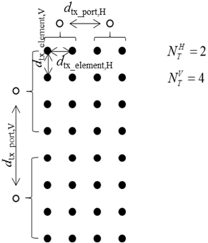

**Figure 18.2.1 Illustration of inter-port spacing**

# Evaluation assumption for peak spectral efficiency and peak data rate

Evaluation parameters for the RITDL peak spectral efficiency and peak data rate is shown in Table 19.1. The notations can be found in equation (1.1) in Section 1.

**Table 19.1 Parameters for DL peak spectral efficiency and peak data rate evaluation**

|  |  |  |
| --- | --- | --- |
| Parameters | Values | Remarks |
| Max. number of layers | For FR1: 8  For FR2: 6, 8 |  |
| Highest modulation order | 8 | 256QAM |
| Scaling factor of modulation | 1 |  |
| Max. coding rate  *Rmax* | 948/1024 = 0.9258 |  |
|  | 0, 1, 2, 3 | SCS = 2μ×15 kHz |
|  | See Table 8.1.1-2 for FR1 and FR2 for specific component carrier bandwidth and SCS. | The maximum number of RBs for the specific component carrier bandwidth and SCS is used. |

The overhead assumption used in the DL evaluation is shown in Table 19.2.

**Table 19.2 Overhead assumption for DL evaluation**

|  |  |  |  |
| --- | --- | --- | --- |
|  | Applied duplexing | FR1 | FR2 |
| OH1 | FDD, TDD (DDDSU) | * PDCCH: CORESET of 24 PRBs (4 CCE) in every slot   + - 12 RE/PRB/slot * TRS burst of 2 slots with periodicity of 20ms and occupies 52 PRBs   + - 12 RE/PRB/20 ms * DMRS: Type 2, 16 RE/PRB/slot for 8 layers * CSI-RS: 8 CSI-RS ports with periodicity of 20ms   + - 8 RE/PRB/20 ms * 1 SS/PBCH blocks (SSB) per 20ms; one SSB occupies 960REs = 4 OFDM symbols × 20 PRB × 12 REs/PRB   NOTE1: if the channel bandwidth is less than the bandwidth of SSB, then SSB is not transmitted and the overhead of SS/PBCH block is zero.  NOTE2: If the channel bandwidth is less than TRS bandwidth, the TRS bandwidth is assumed to be equal to the channel bandwidth. | * PDCCH: CORESET of 24 PRBs (4 CCE) in every slot   + 12 RE/PRB/slot * TRS burst of 2 slots with periodicity of 10ms and occupies 52 PRBs   + 12 RE/PRB/slot * DMRS: Type 2, 12 RE/PRB/slot for 6 layers * CSI-RS: 8 CSI-RS ports with periodicity of 10ms   + - 8 RE/PRB/10 ms * 8 SSB per 20ms; one SSB occupies 960REs = 4 OFDM symbols × 20 PRB × 12 REs/PRB * PTRS: 1 port, frequency density is 4 PRB, and time domain density is 1 symbol * CSI-RS for BM: 1 CSI-RS port with periodicity of 10ms   + 2 RE/PRB/10ms   NOTE: If the channel bandwidth is less than TRS bandwidth, the TRS bandwidth is assumed to be equal to the channel bandwidth. |
| OH2 | FDD, TDD (DDDSU) | * PDCCH: 2 CEE   + - 144 RE/slot * TRS burst of 2 slots with periodicity of 80ms and occupies 52 PRBs   + - 12 RE/PRB/80 ms * DMRS: Type 2, 16 RE/PRB/slot * CSI-RS: 8 CSI-RS ports with periodicity of 20ms   + - 8 RE/PRB/20 ms * CSI-IM: 4 CSI-RS ports with periodicity of 20ms   + - 4 RE/PRB/20 ms * 1 SSB   960 RE/20 ms | - |
| OH3 | FDD, TDD (DSUUD, S slot = 11DL:1GP:2UL) | * PDCCH: 4 CCE in every slot * TRS: min(52, NRBBWP) PRB wide, occurs every 80 ms * DMRS: Type 2, 16 RE/PRB/slot * CSI-RS: 8 CSI-RS ports with 1 RE/RB/port, with periodicity of 20ms * CSI-IM: 4 RE/PRB, with periodicity of 20ms * 1 SSB per 20ms   NOTE1: If the number of REs is less than 240 at the evaluated channel bandwidth and SCS, the SSB is assumed transmitted by lower SCS and the overhead of SS/PBCH block is 1 SSB per 20ms. | * PDCCH: 4 CCE in every slot * TRS: min(52, NRBBWP) PRB wide, occurs every 10 ms * DMRS: Type 2, 12 RE/PRB/slot * CSI-RS: 8 CSI-RS ports with 1 RE/RB/port, with periodicity of 2.5ms * CSI-IM: 4 RE/PRB, with periodicity of 2.5ms * 8 SSB per 20ms * PTRS: 1 port, frequency density is 4 PRB, and time domain density is 1 symbol |
| OH4 | FDD, TDD (DSUUD, S slot = 6DL:2GP:6UL) | Overhead is adapted to 0.14 to match the capability of T3.9038.306  For FDD:   * PDCCH: 4 CCE + 1 symbol per slot   + - 12*24 RE/slot * TRS   + - 2x4 RE/PRB/20 slots * DMRS: 2 symbol Type 2 FL DMRS with RS on 2 coMbs   + - 16 RE/PRB/slot * CSI-RS: 8-port CSI-RS resources   + - 8 RE/PRB/10 slots * 1 SSB   + - 960 RE/20 slots   For TDD:   * PDCCH: 2 CCE + 1 symbol per slot   + - 12*12 RE/slot * TRS   + - 2x4 RE/PRB/40 slots * DMRS: 2 symbol Type 2 FL DMRS with RS on 2 combs   + - 16 RE/PRB/slot * CSI-RS: 8-port CSI-RS resources   + - 8 RE/PRB/20 slots * 1 SSB   + - 960 RE/20 slots | Overhead is adapted to 0.18 to match the capability of T3.9038.306   * PDCCH: 4 CCE + 1 symbol per slot   + - 12*24 RE/slot * TRS   + - 8 RE/PRB/16 slots * DMRS: 2 symbol Type 2 FL DMRS with RS on 2 combs   + - 16 RE/PRB/slot * CSI-RS: 8-port CSI-RS resources   + - 8 RE/PRB/16 slots * 8 SSB   + - 8x960 RE/PRB/80 slots |

Evaluation parameters for UL peak spectral efficiency and peak data rate is shown in Table 19.3. The notations can be found in equation (1.1) in Section 1

**Table 19.3 Parameters for UL peak spectral efficiency and peak data rate evaluation**

|  |  |  |
| --- | --- | --- |
| Parameters | Values | Remarks |
| Max. number of layers | 4 |  |
| Highest modulation order | 8 | 256QAM |
| Scaling factor of modulation | 1 |  |
| Max. coding rate  *Rmax* | 948/1024 = 0.9258 |  |
|  | 0, 1, 2, 3 | SCS = 2μ×15 kHz |
|  | See Table 8.1.1-2 for FR1 and FR2 for specific component carrier bandwidth and SCS. | The maximum number of RBs for the specific component carrier bandwidth and SCS is used. |

The overhead assumption used in the UL evaluation is shown in Table 19.4.

**Table 19.4 Overhead assumption for UL evaluation**

|  |  |  |  |
| --- | --- | --- | --- |
|  | Applied duplexing | FR1 | FR2 |
| OH1 | FDD, TDD (DDDSU) | * PUCCH: short PUCCH with 1 PRB and 1 symbol in every UL slot; 12 RE/slot * DMRS: Type I, one complete symbol; 12 RE/PRB/slot * SRS: 1 symbol with periodicity of 10ms for FDD; 1 symbol with periodicity of 20ms for TDD | * PUCCH: short PUCCH with 1 PRB and 1 symbol in every UL slot; 12 RE/slot * DMRS: Type I, one complete symbol; 12 RE/PRB/slot * SRS: 1 symbol with periodicity of 5ms * PTRS: 2 ports PTRS, frequency density is 4 PRB, and time domain density is 1 symbol |
| OH2 | FDD, TDD (DDDSU) | * PUCCH: short PUCCH with 1 PRB and 1 symbol in every UL slot; 12 RE/slot * DMRS: Type II, 8 RE/PRB/slot * SRS: 1 symbol with periodicity of 20ms | - |
| OH3 | FDD, TDD (DSUUD, S slot = 11DL:1GP:2UL) | * PUCCH: short PUCCH with 1 PRB over 1 symbol in every slot; * DMRS: Type II, 8 RE/PRB/slot for slot carrying SRS; otherwise 12 RE/PRB/slot. * SRS: Resources ensuring the whole bandwidth measured within 20ms | * PUCCH: short PUCCH with 1 PRB over 1 symbol in every slot; * DMRS: Type I, 12 RE/PRB/slot * SRS: Resources ensuring the whole bandwidth measured within 2.5ms * PTRS: 2 ports, frequency density is 4 RB, and time domain density is 1 symbol |
| OH4 | FDD, TDD (DSUUD, S slot = 6DL:2GP:6UL) | Overhead is adapted to 0.08 to match the capability of T3. 9038.306.  For FDD:   * PUCCH: short PUCCH with 2 symbols and 8 PRBs;   + - 192 RE per slot * DMRS: 1 symbol Type 2 FL DMRS in each slot with RS on 2 combs;   + - 8 RE/PRB/slot * SRS * 12 RE/PRB/5 slots   For TDD:   * PUCCH: short PUCCH with 2 symbols and 8 PRBs;   + - 192 RE/2 slots * DMRS: 1 symbol Type 2 FL DMRS in each slot with RS on 2 combs;   + - 8 RE/PRB/slot * SRS * 12 RE/PRB/10 slots | Overhead is adapted to 0.1 to match the capability of T3. 9038.306.   * PUCCH: short PUCCH with 2 symbols and 8 PRBs;   + - 192 RE/2 slots * DMRS: 1 symbol Type 2 FL DMRS in each slot with RS on 2 combs;   + - 8 RE/PRB/slot * SRS   + - 12 RE/PRB/5 slots |

# Coverage Enhancement with Pi/2 BPSK and Spectrum Shaping

In this section, we provide additional coverage results using this power boost (26 dBm TX power with 50% duty cycle) feature as supplementary information.

* RIT introduces an LMLC waveform
  + pi/2 BPSK with spectrum shaping feature using unfiltered DMRS
  + When pi/2 BPSK is enabled, UE transmits up to 26 dBm max power compared to 23 dBm for QPSK case
* We quantify the benefit of using LMLC waveform using multi-cell system-level-simulation

|  |  |
| --- | --- |
| **Parameter** | **Value** |
| ISD | 12 Km |
| fc | 3.5 GHz TDD |
| Antenna (UE, BTS) | (1,2), (1,4) and 18 dB gain sectoral antenna |
| BS height | 35m |
| UE height | 1.5m |
| Bandwidth | 60 MHz |
| UE transmit power | 23 dBm (without pi/2 bpsk), 26 dBm (for pi/2 bpsk) |
| Pathloss Model | LMLC (ITU-R M.2412-0) |
| 10 UEs/sector | Available RBs are equally shared among the UEs |

|  |  |  |  |  |
| --- | --- | --- | --- | --- |
| **ISD=12 Km**  **(Rx=2 antenna)** | UE throughput (in Mbps) | | Spectral Efficiency (bps/Hz) | |
| w/o pi/2 bpsk | pi/2 bpsk | w/o pi/2 bpsk | pi/2 bpsk |
| 5% | 0.6722 | 1.232 | 0.1008 | 0.180 |
| 10% | 0.9453 | 1.665 | 0.1409 | 0.2497 |
| 50% | 2.719 | 3.09 | 0.4079 | 0.4635 |

|  |  |  |  |  |
| --- | --- | --- | --- | --- |
| **ISD=12 Km**  **(Rx=4 antenna)** | UE throughput (in Mbps) | | Spectral Efficiency (bps/Hz) | |
| w/o pi/2 bpsk | pi/2 bpsk | w/o pi/2 bpsk | pi/2 bpsk |
| 5% | 1.232 | 2.276 | 0.181 | 0.3413 |
| 10% | 1.665 | 2.552 | 0.2497 | 0.3827 |
| 50% | 4.607 | 4.747 | 0.6913 | 0.7121 |

Pi/2 BPSK with spectrum shaping enables 5G large cell 12-Km ISD rural deployment at 3.5GHz TDD

* For the same data rate and ISD
  + Approximate 2X increase in UE throughput over QPSK using 2-rx antennas
  + 60MHz BW, 10 UEs per sector, each UE get >1 Mbps due to pi/2 BPSK
* Or QPSK requires twice higher number of receiver antennas to maintain same cell edge performance as pi/2 BPSK – higher BTS cost
* For the same data rate requirement, pi/2 BPSK offers higher cell range since QPSK modulation results in very low data rates for some cell edge UE

# Detailed Evaluation Assumptions

## Spectral Efficiency

|  |  |  |
| --- | --- | --- |
| Indoor Hotspot | Dense Urban | Rural |
|  |  |  |

## Mobility

|  |  |  |
| --- | --- | --- |
| Indoor Hotspot | Dense Urban | Rural |
|  |  |  |

## Reliability



## Connection Density

